# GitHub Notes

GitHub Notes 1

Git hub main two repository to work on it. 1

GitHub Notes 2

Git :- 2

GitHub:- 2

Setting up Git:- 2

Configuring Git:- 2

Clone & Status 2

Add & Commit 5

Push Command 6

WorkFlow :- 13

Local Github 13

Git Branches:- 13

Branch Commands 13

Merging Code 15

1 ) git diff main 16

2)Create PR (Pull Request) 16

Pull Command 20

Resolving Merge Conflicts 20

Undoing Changes 27

Case 1: staged changes 27

Case 2: Commited changes (for one commit) 28

Case 3: commited changes (for many commits) 30

Push on site commit Deleted 30

Fork 36

## Git hub main two repository to work on it.

1. All Notes here uploaded.

<https://github.com/Ranjitk0001/noteGitHub>

2)

<https://github.com/Ranjitk0001/LocalRepo>

# GitHub Notes

## Git :-

Version Control System is a tools that helps to track changes in code.

Git is a **Version Control System. It is:-**

Popular

Free & Open Source

Fast & Scalable

## GitHub:-

**Website** that allows developers to store and manage their code using Git.

<https://github.com>

GitHub Account

Create a new repository :-

Make out first commit

## Setting up Git:-

Visual Studio Code

Windows (Git Bash)

Mac (Terminal)

Git –version

## Configuring Git:-

Git config –global user.name “ranjitk0001”

Git config –global user.name [ranjitkale0001@gmail.com](mailto:ranjitkale0001@gmail.com)

Git config –list

## Clone & Status

**Clone** – Cloning a repository on our local machine.

Git clone <- some link->

**Status** – Displays the state of the code.

Git status

1)

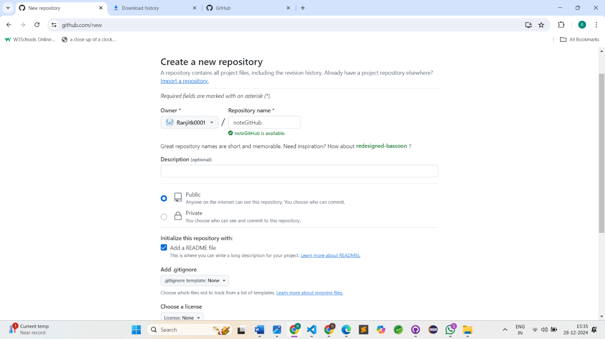

2)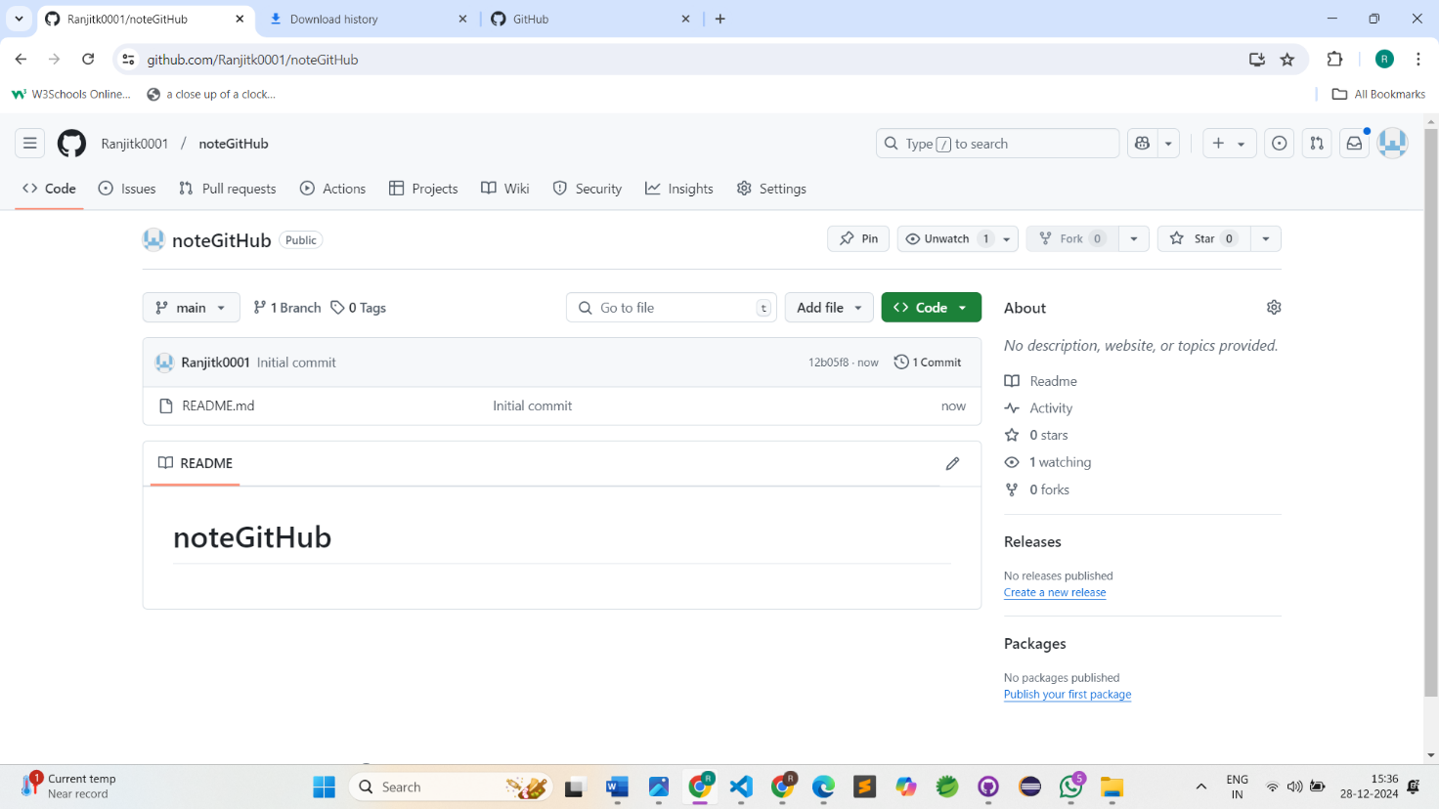

3)

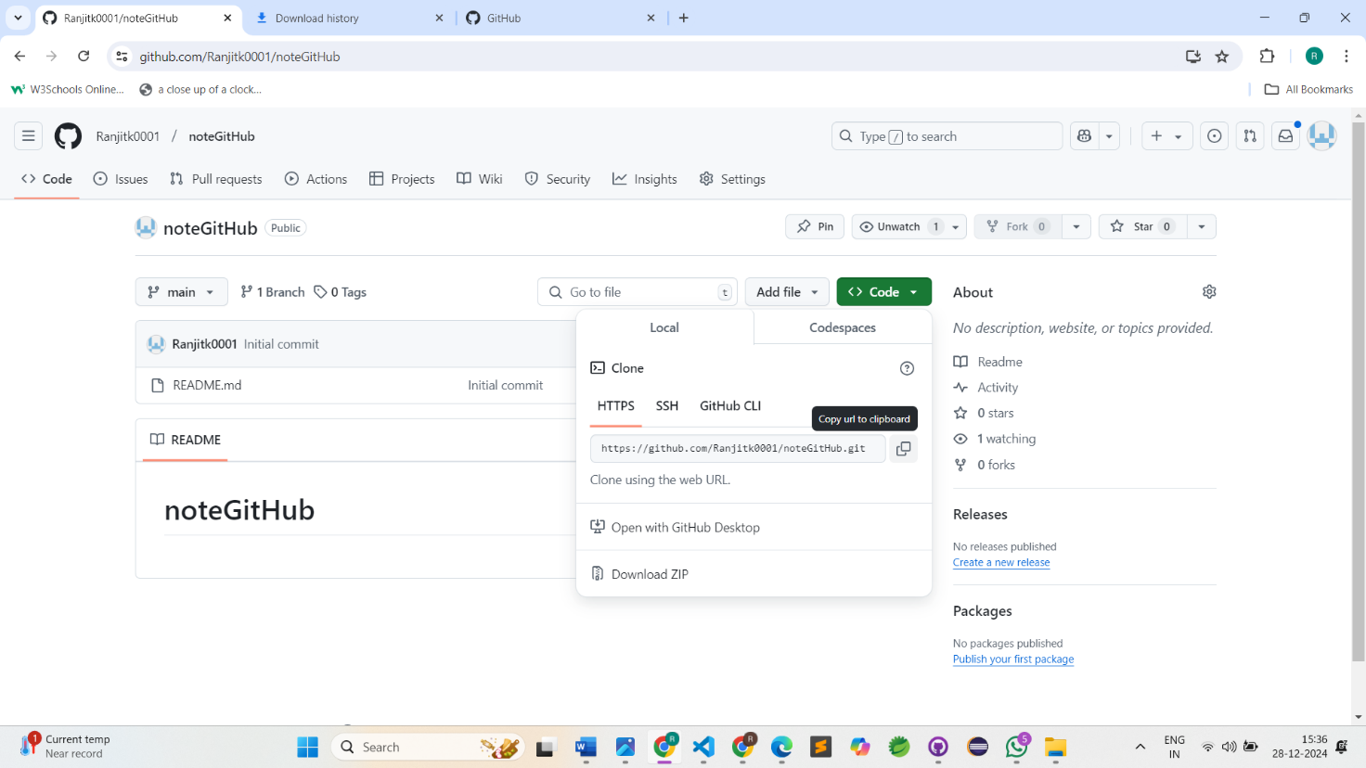

4)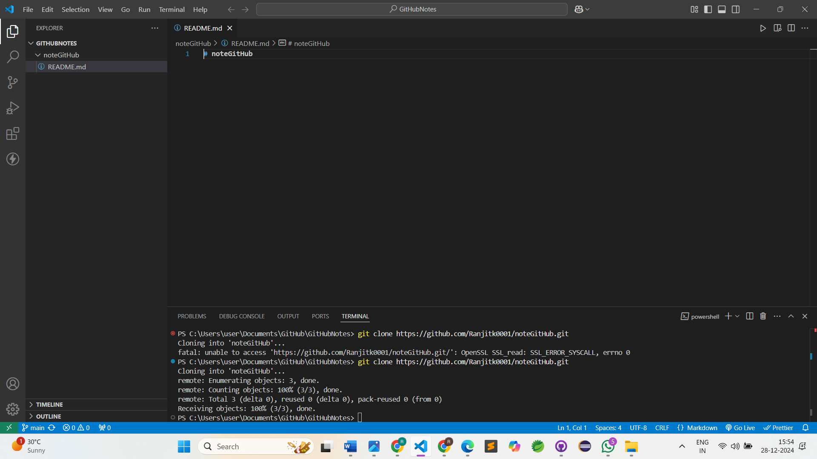

5)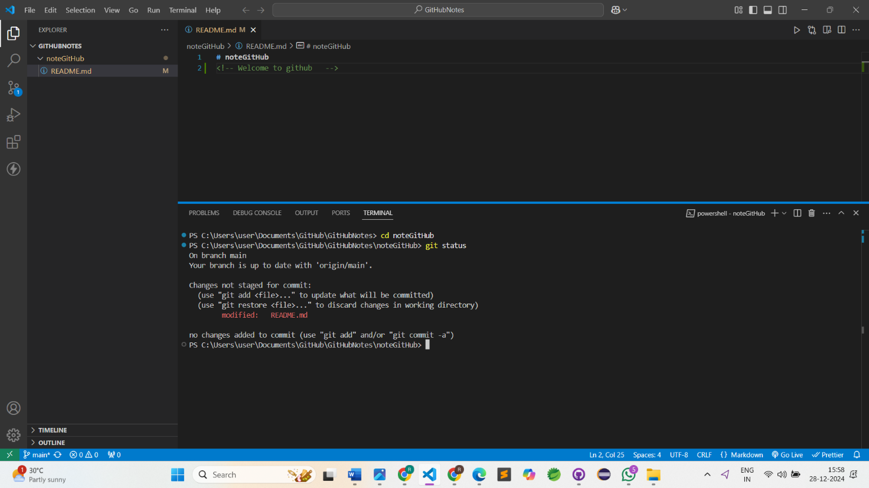

**PS C:\Users\user\Documents\GitHub\GitHubNotes\noteGitHub> ls(**list of file**)**

Directory: C:\Users\user\Documents\GitHub\GitHubNotes\noteGitHub

Mode LastWriteTime Length Name

---- ------------- ------ ----

-a ---- 28-12-2024 15:55 42 README.md

**Untracked**

New file that git doen’t yet track.

**Modified**

Change

**Staged**

File is ready to be committed

**Unmodified**

Unchanged

## Add & Commit

**Add :-** add new or changed files in your working directory to Git staging area.

i)Single file

git add <-file name->

ii) Multiple files

git add _ .

**Commit:-** it is the record of change

git commit -m “First Commit”

## Push Command

**Push** – upload local repository content to remote repository

git push origin main

6)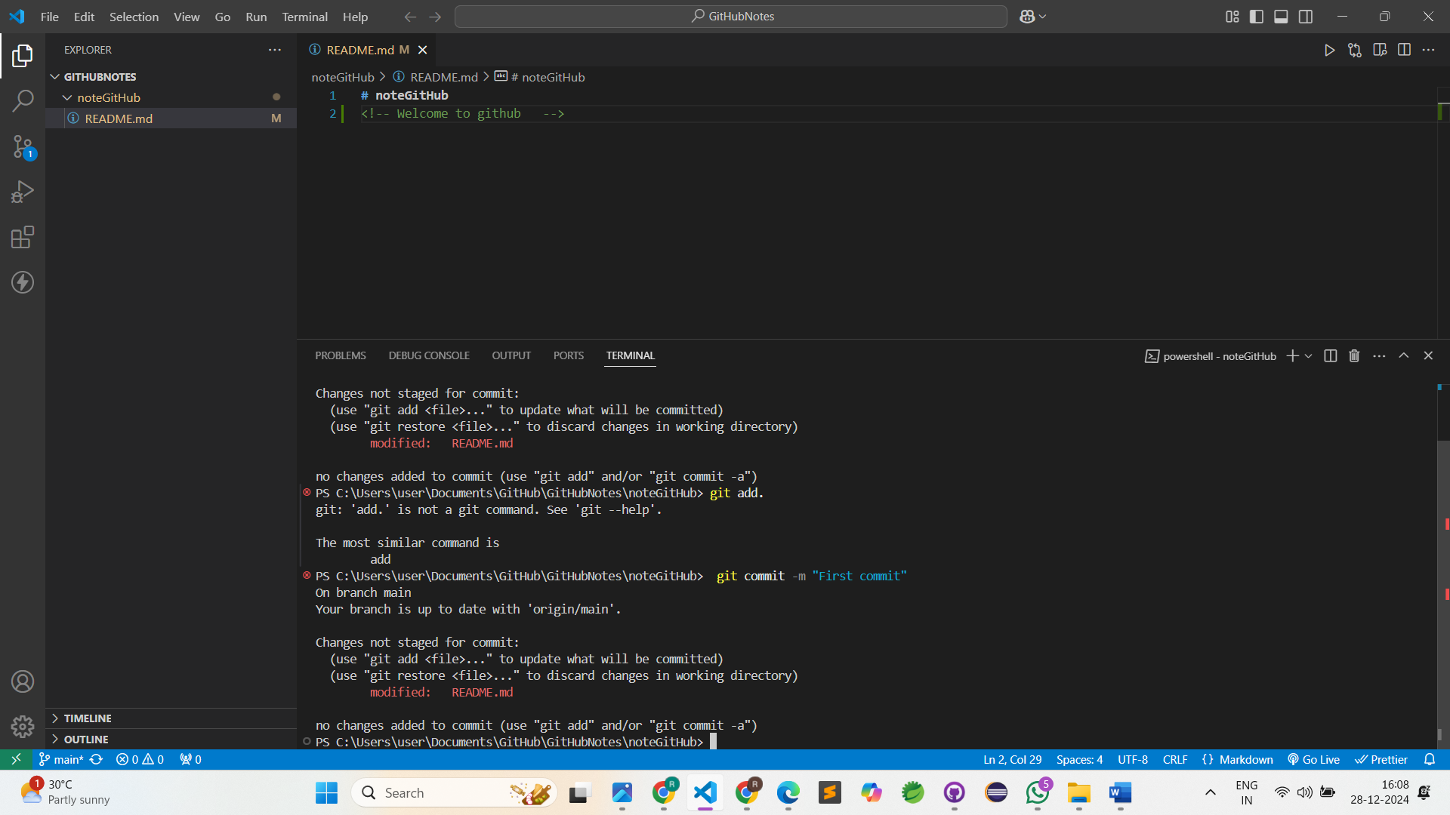

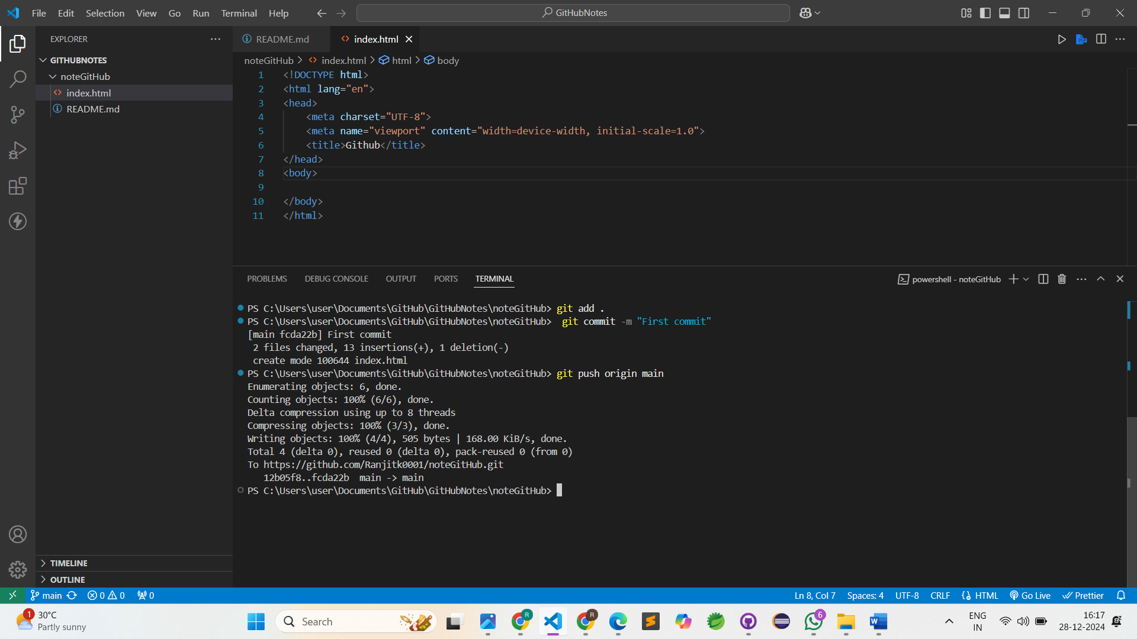

Init Command

**Init :-** used to create a new git repo

git init

git remote add origin <-link->

git remote -v (to verify remote)

git branch -M main (to rename branch)

git push origin main

1)

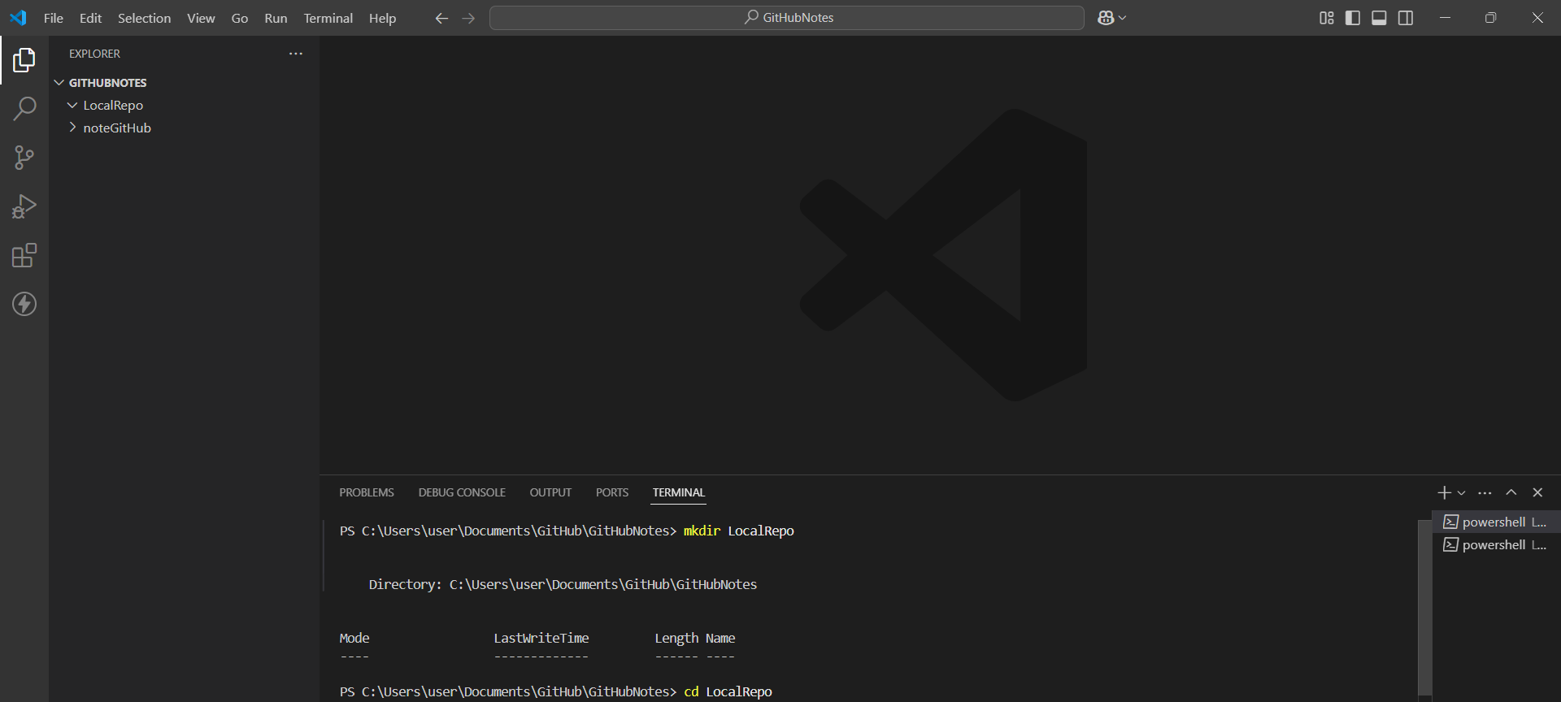

2)

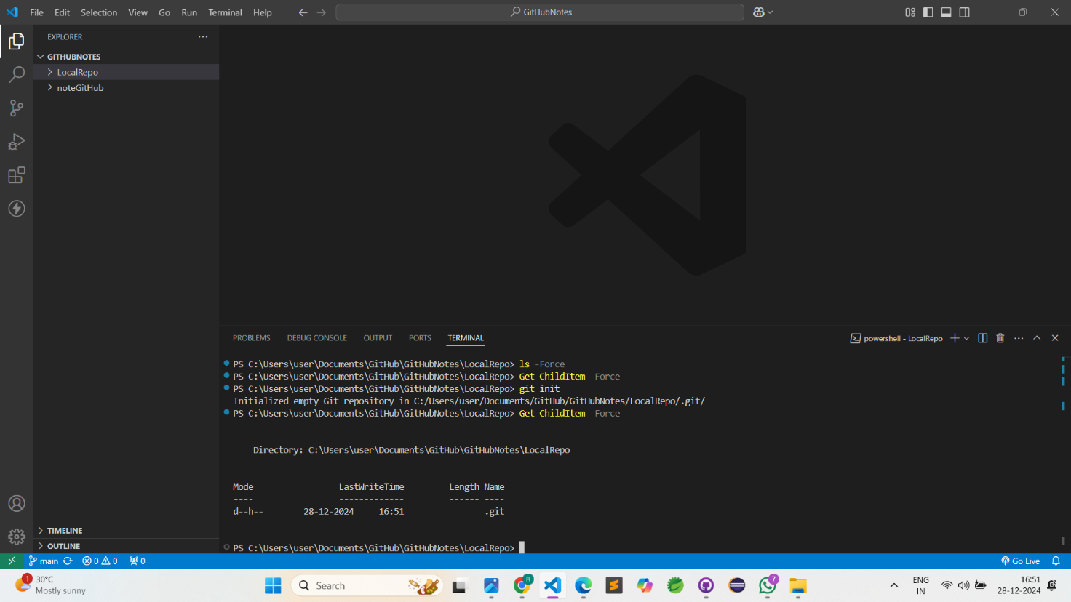

3)

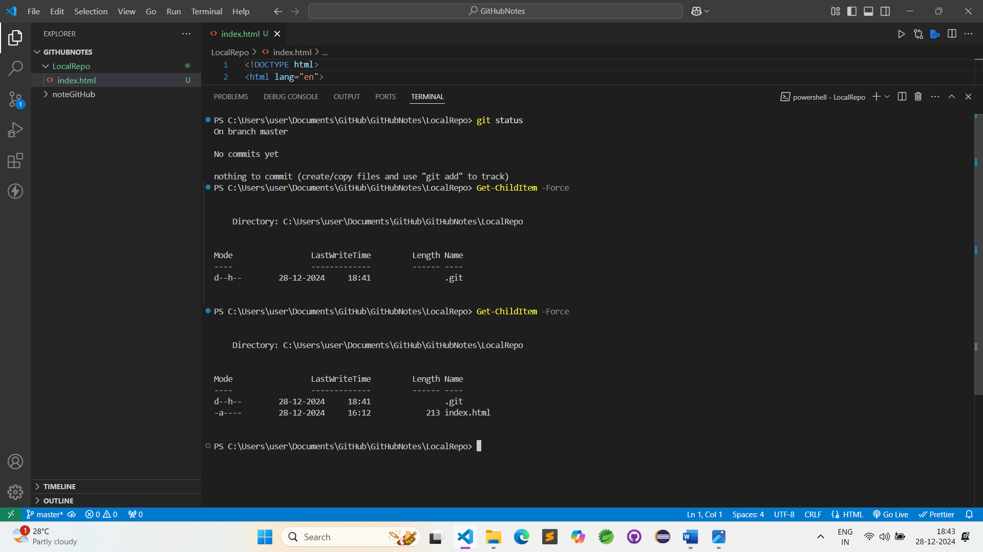

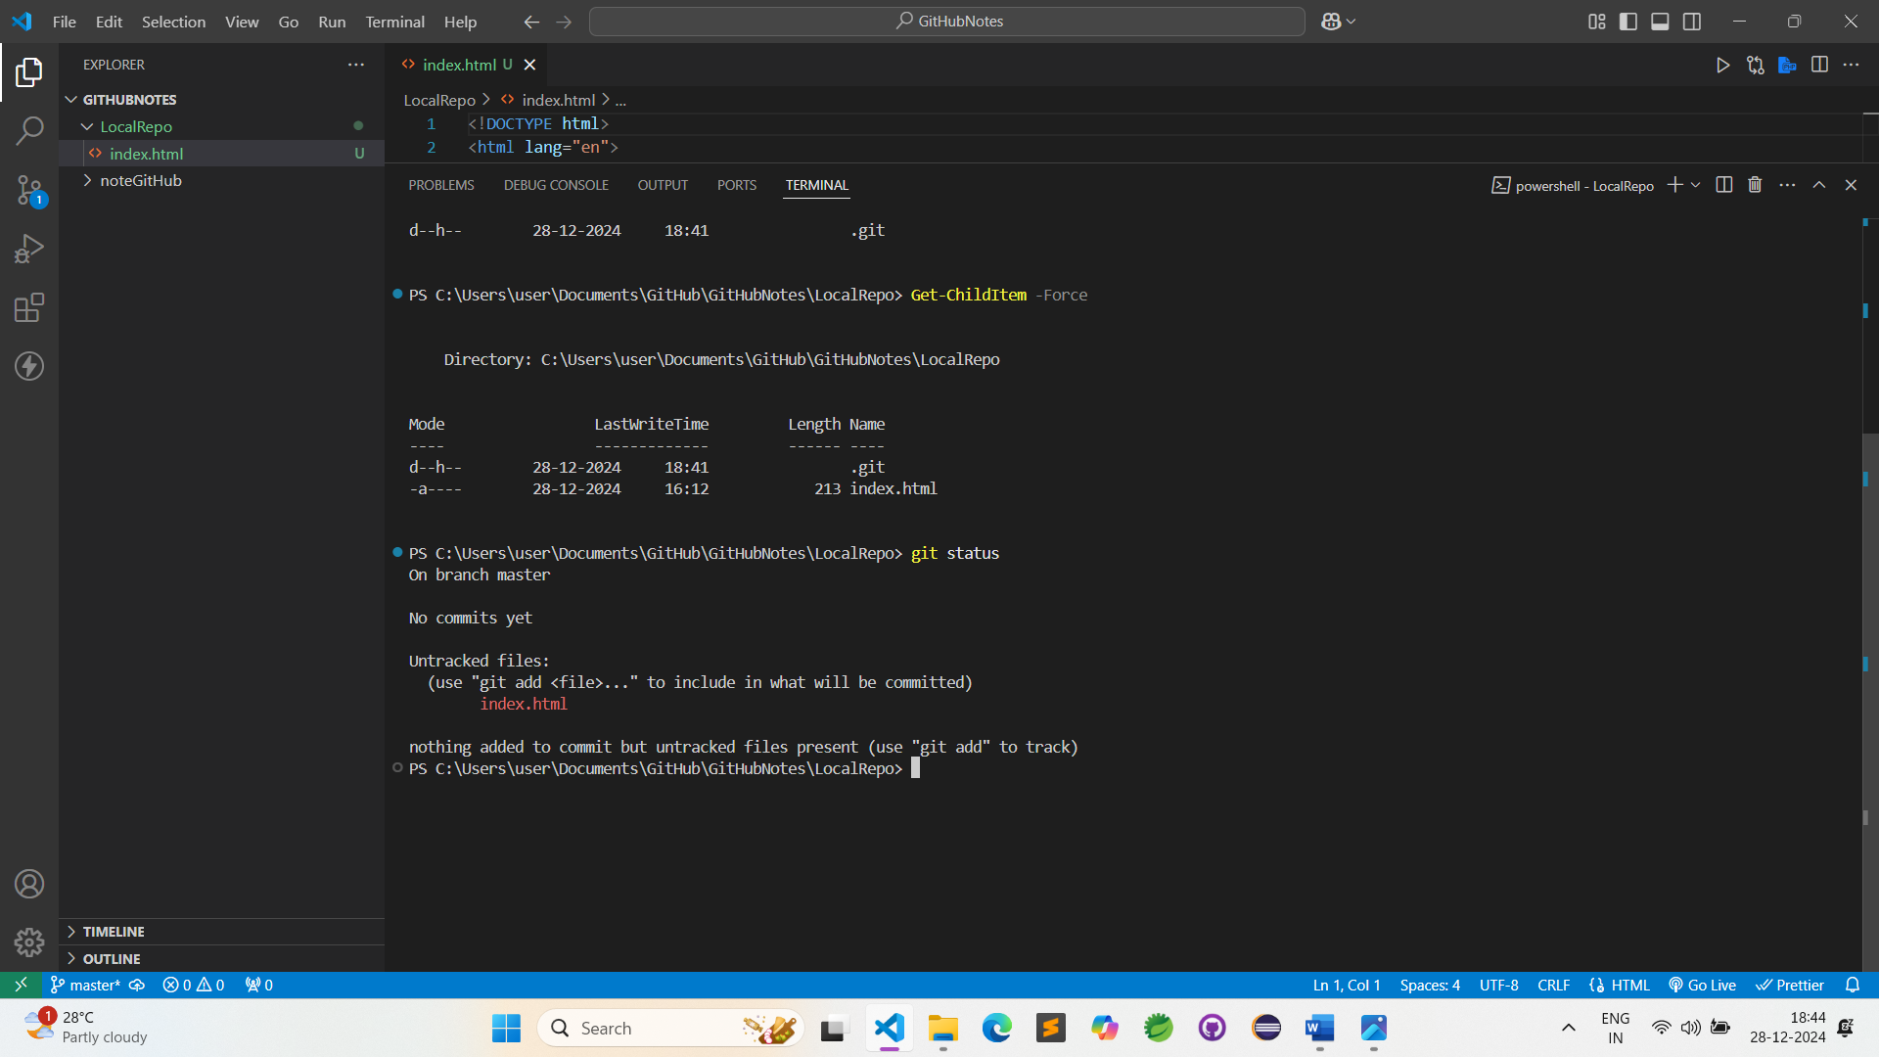

4)

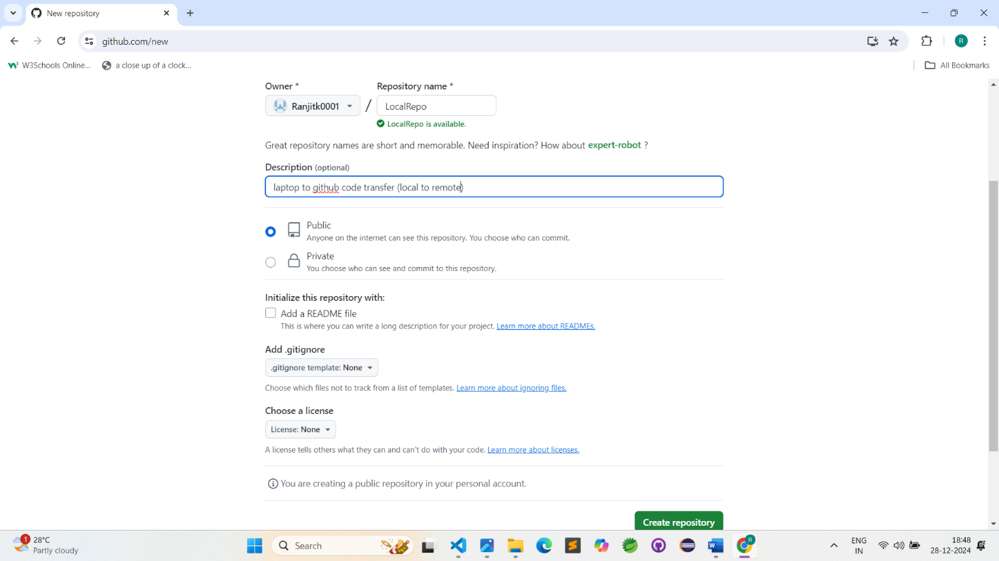

5)

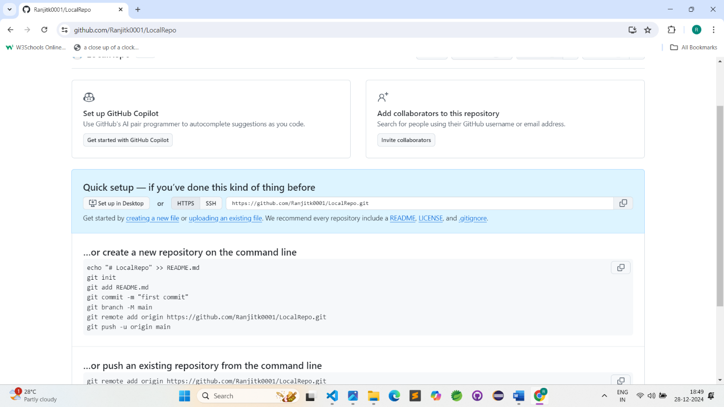

6)

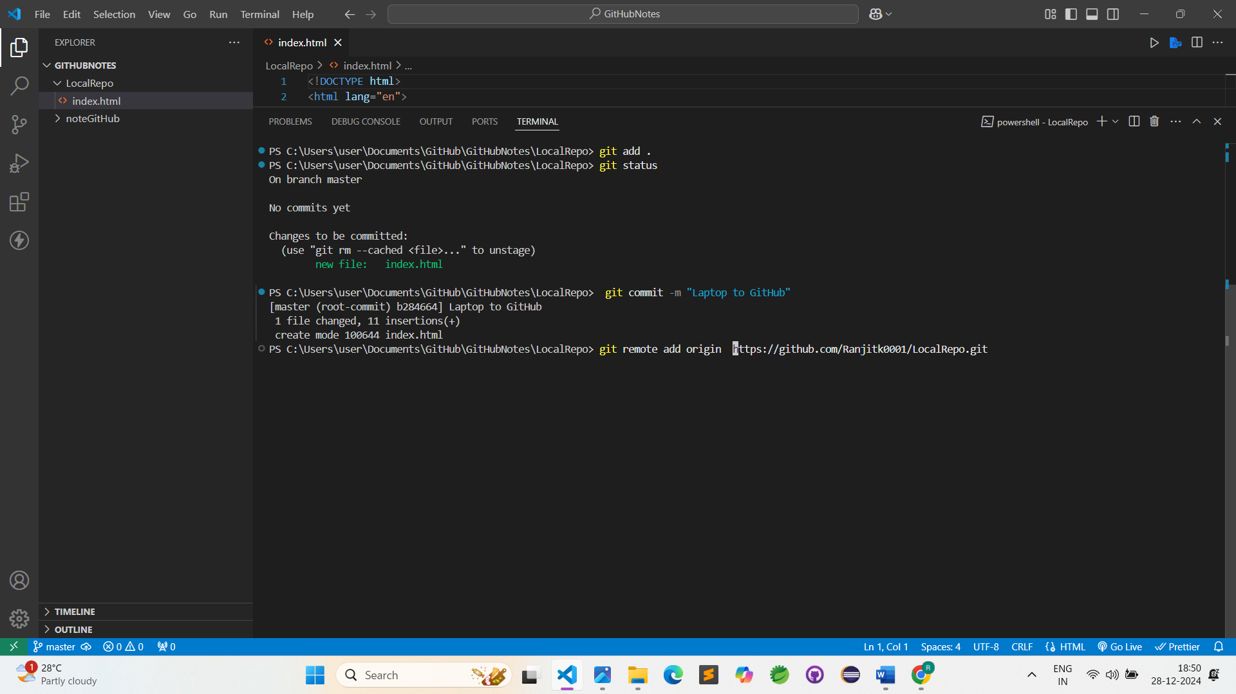

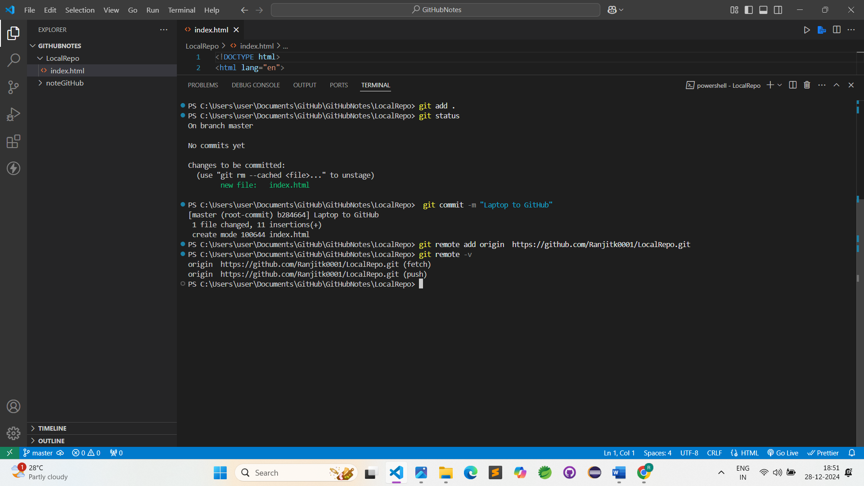

7)

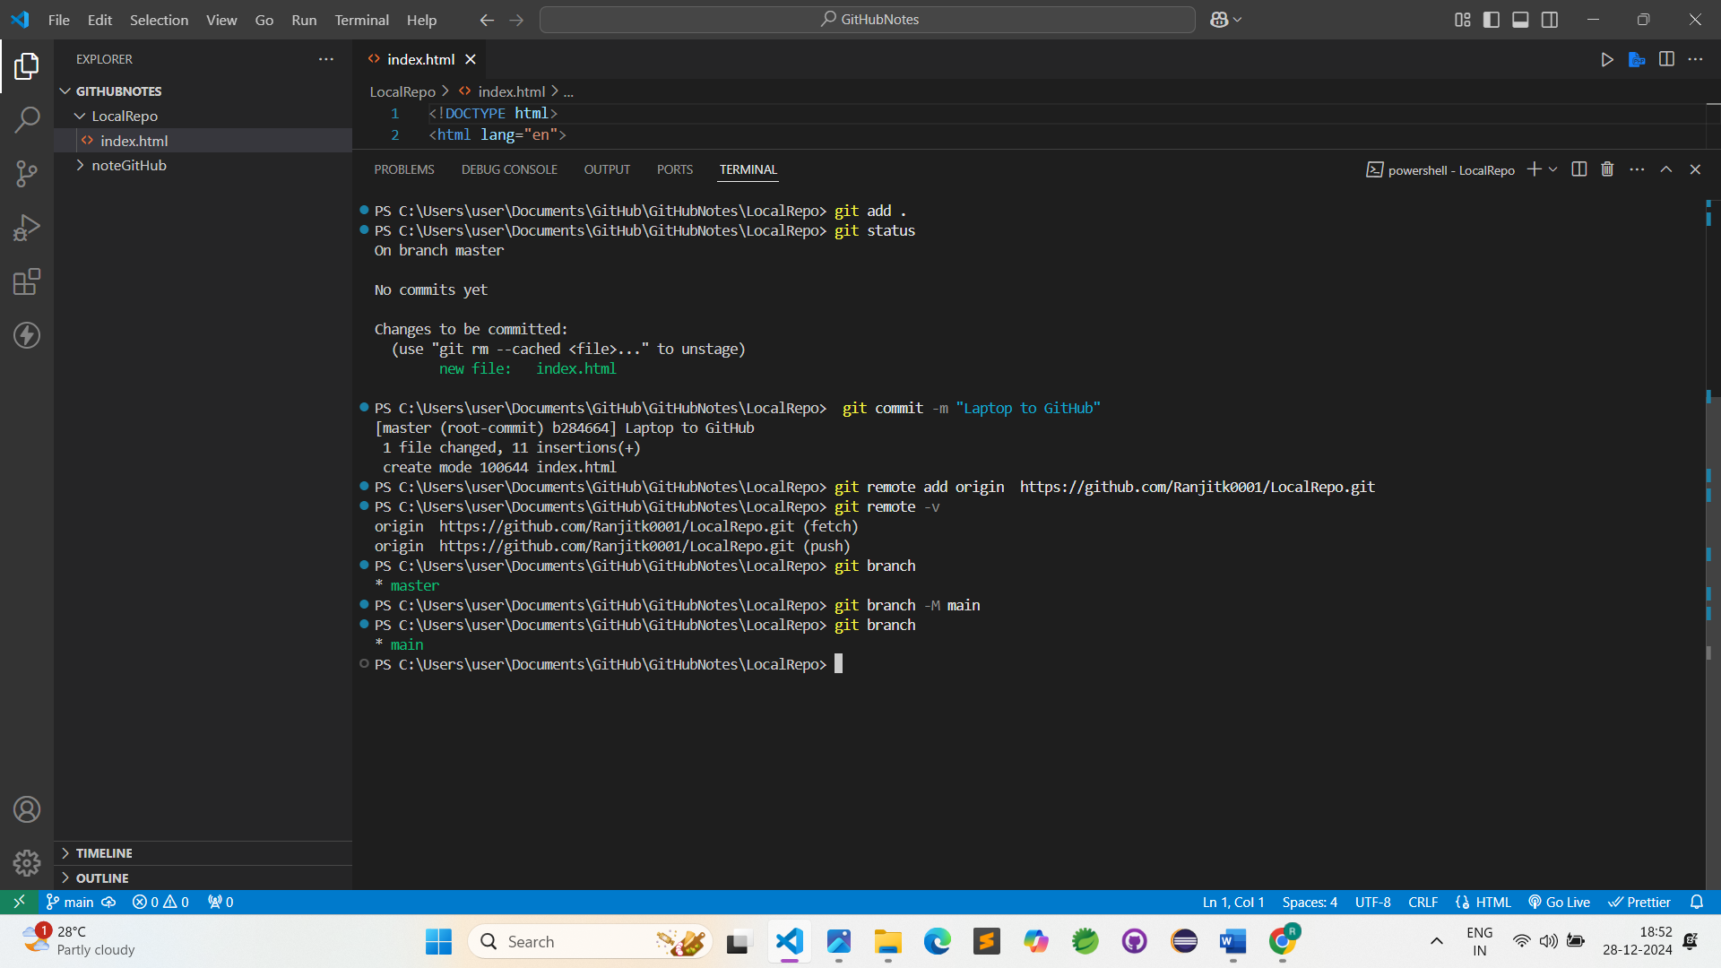

8)

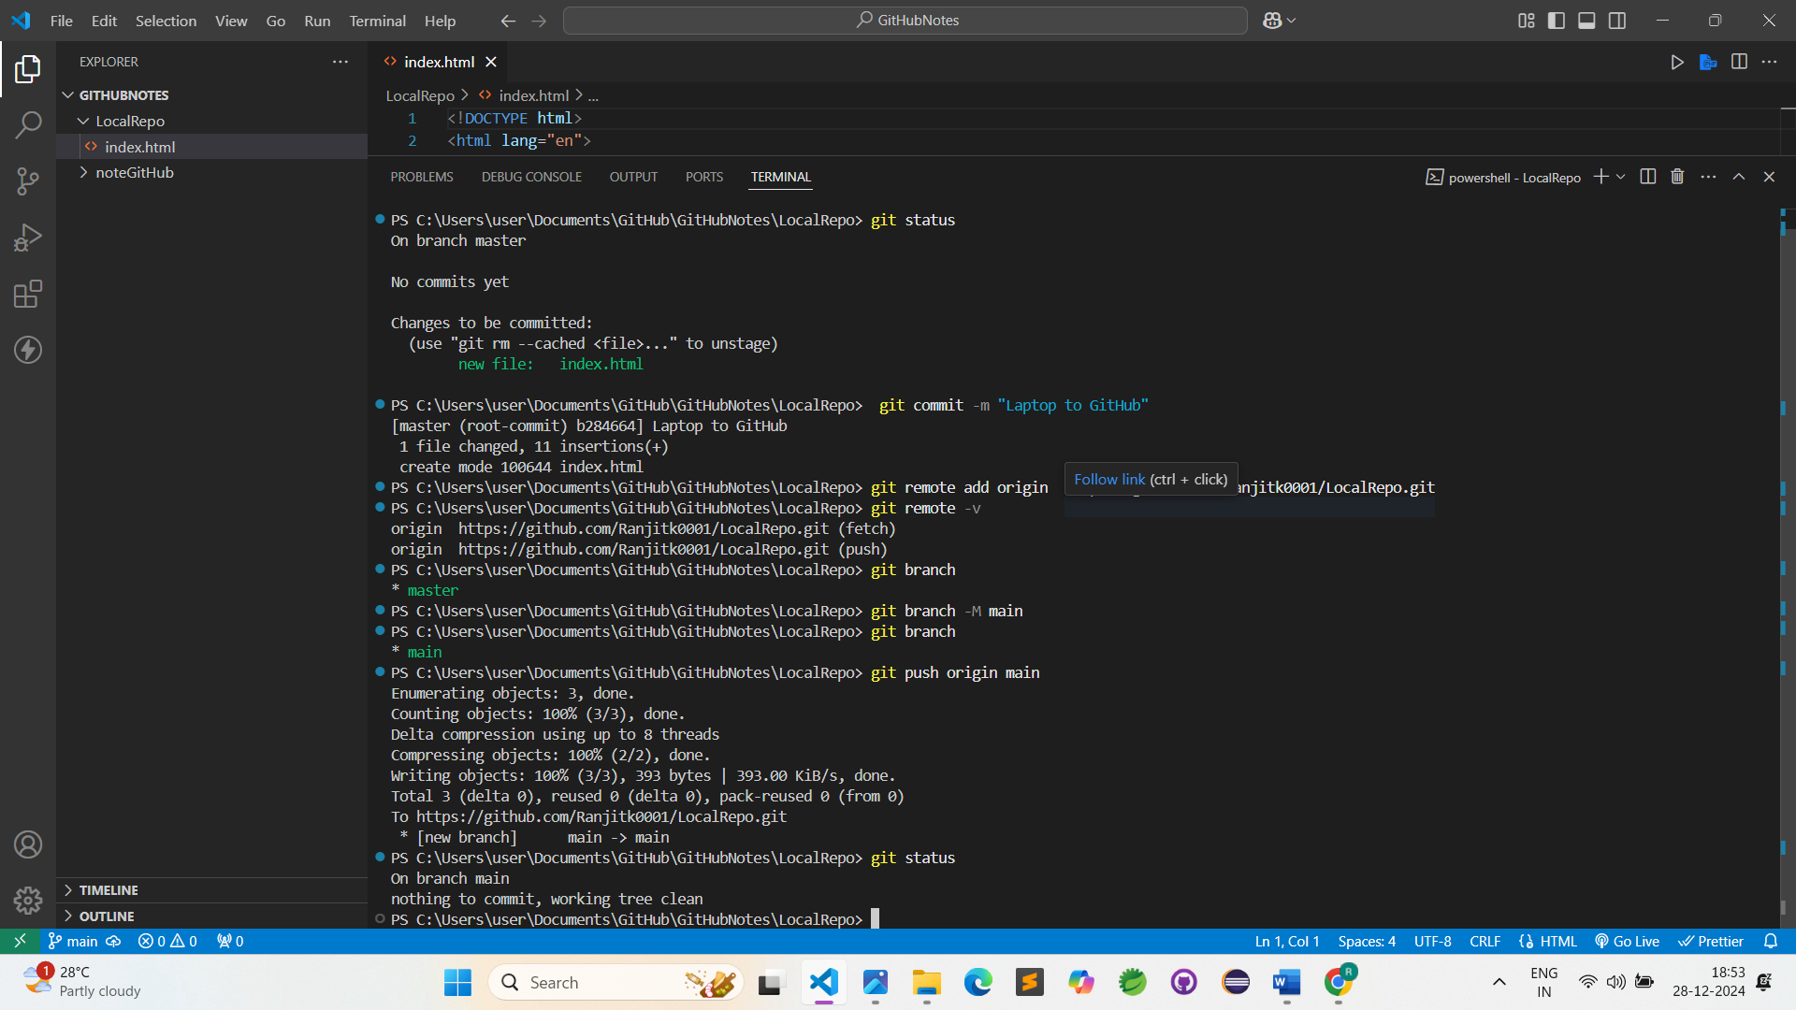

9)

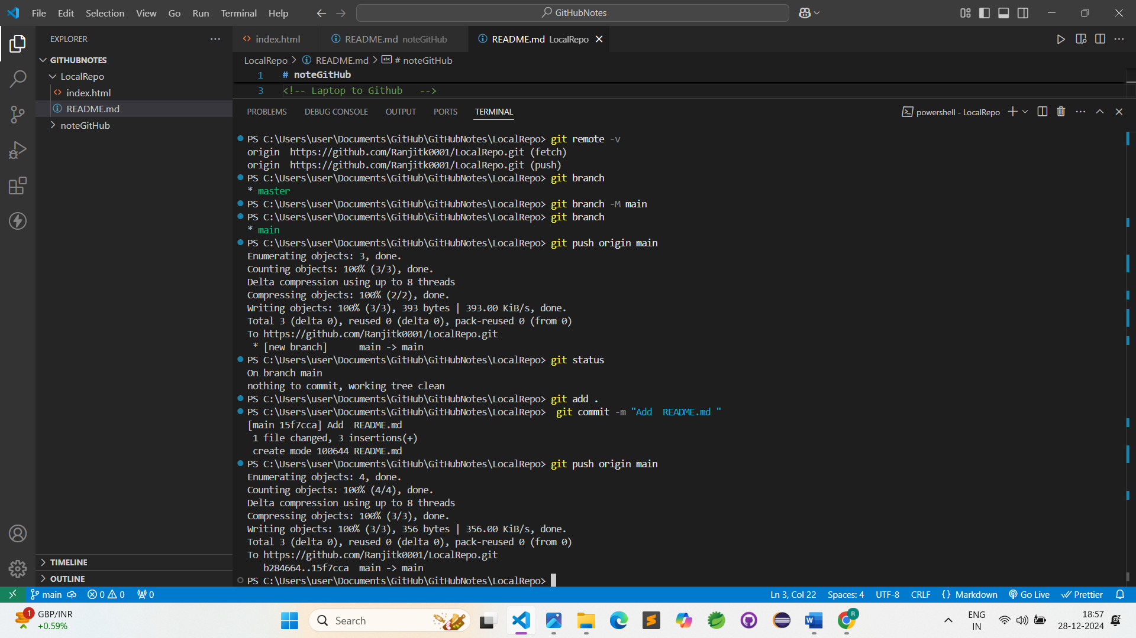

## WorkFlow :-

### Local Github

GitHub Repository 🡪 Clone 🡪 changes 🡪 add 🡪 commit 🡪push

## Git Branches:-

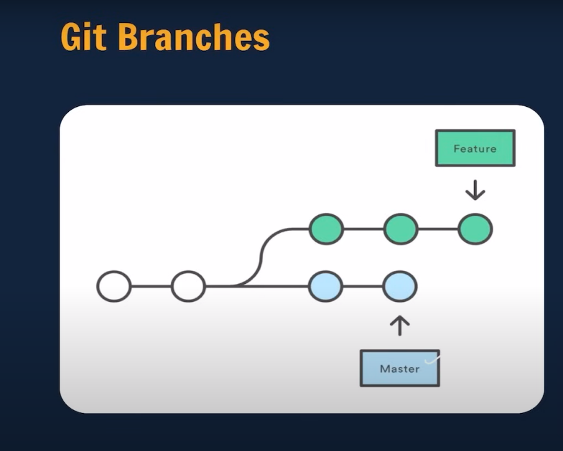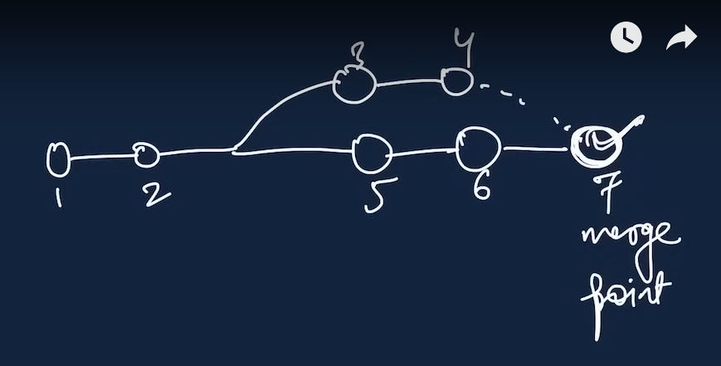

## Branch Commands

* git branch (**to check branch**)
* git branch -M main (**to rename branch**)
* git checkout <- branch name -> (**to navigate**)
* git checkout -b<- new branch name-> (**to create new branch**)
* git branch -d <- branch name-> (**to delete branch**)

1)

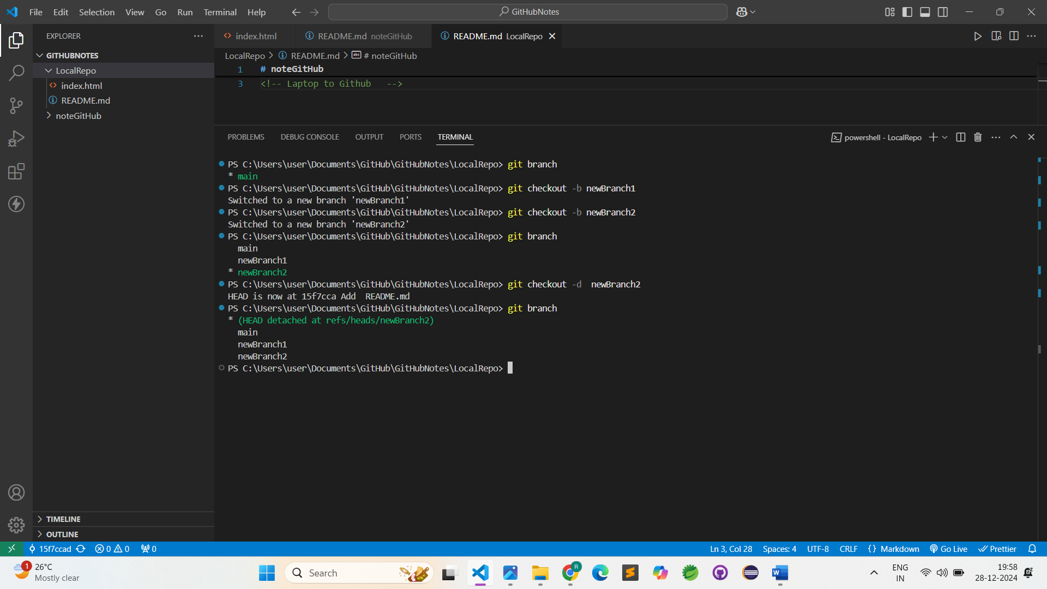

2)

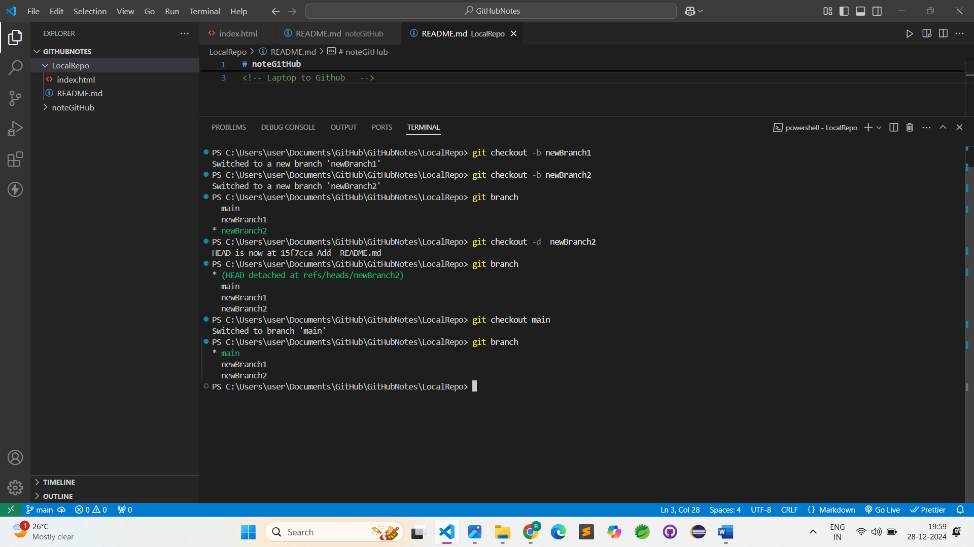

3)Delete Branch

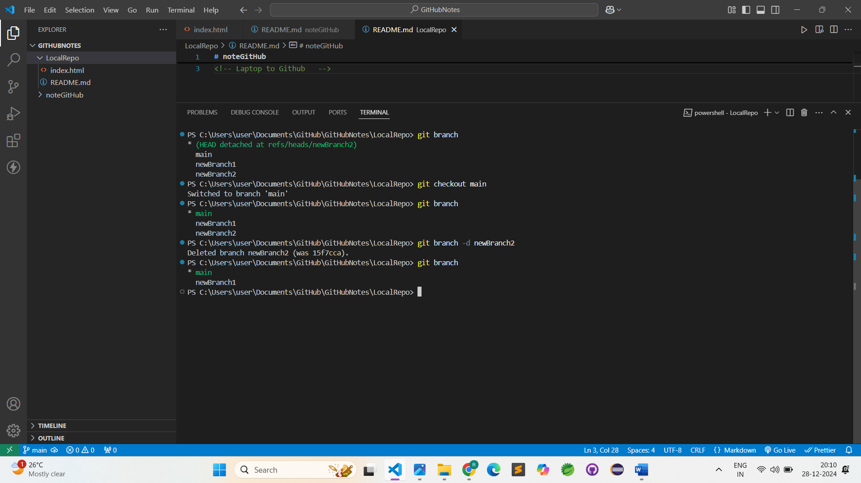

4)Adding data new branch in newBranch1

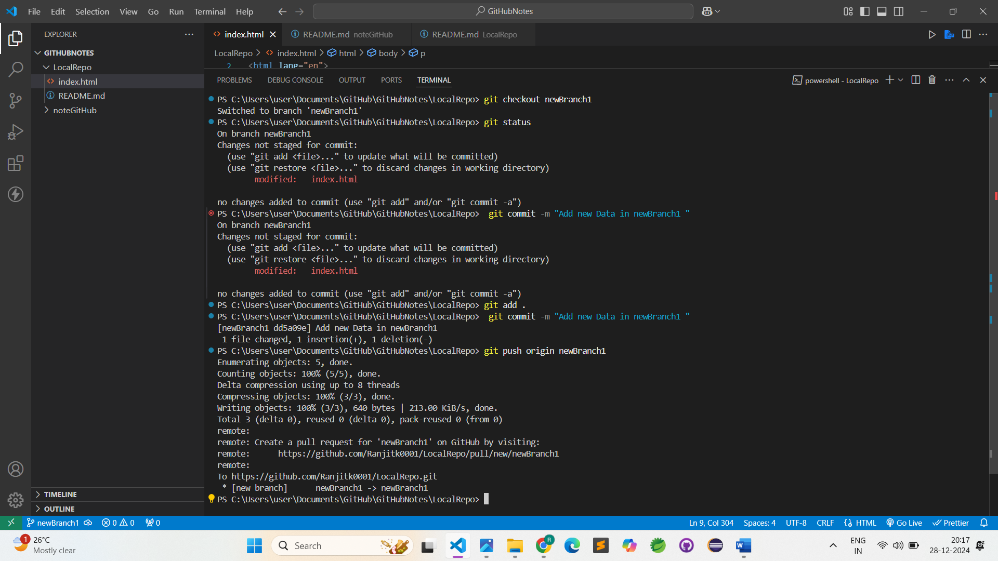

## Merging Code

**Way1:-**

git diff <- branch name-> (**to compare commits , branches, file& more**)

git merge <-branch name-> (to merge 2 branches)

**Way2:-**

Create a PR

### 1 ) git diff main

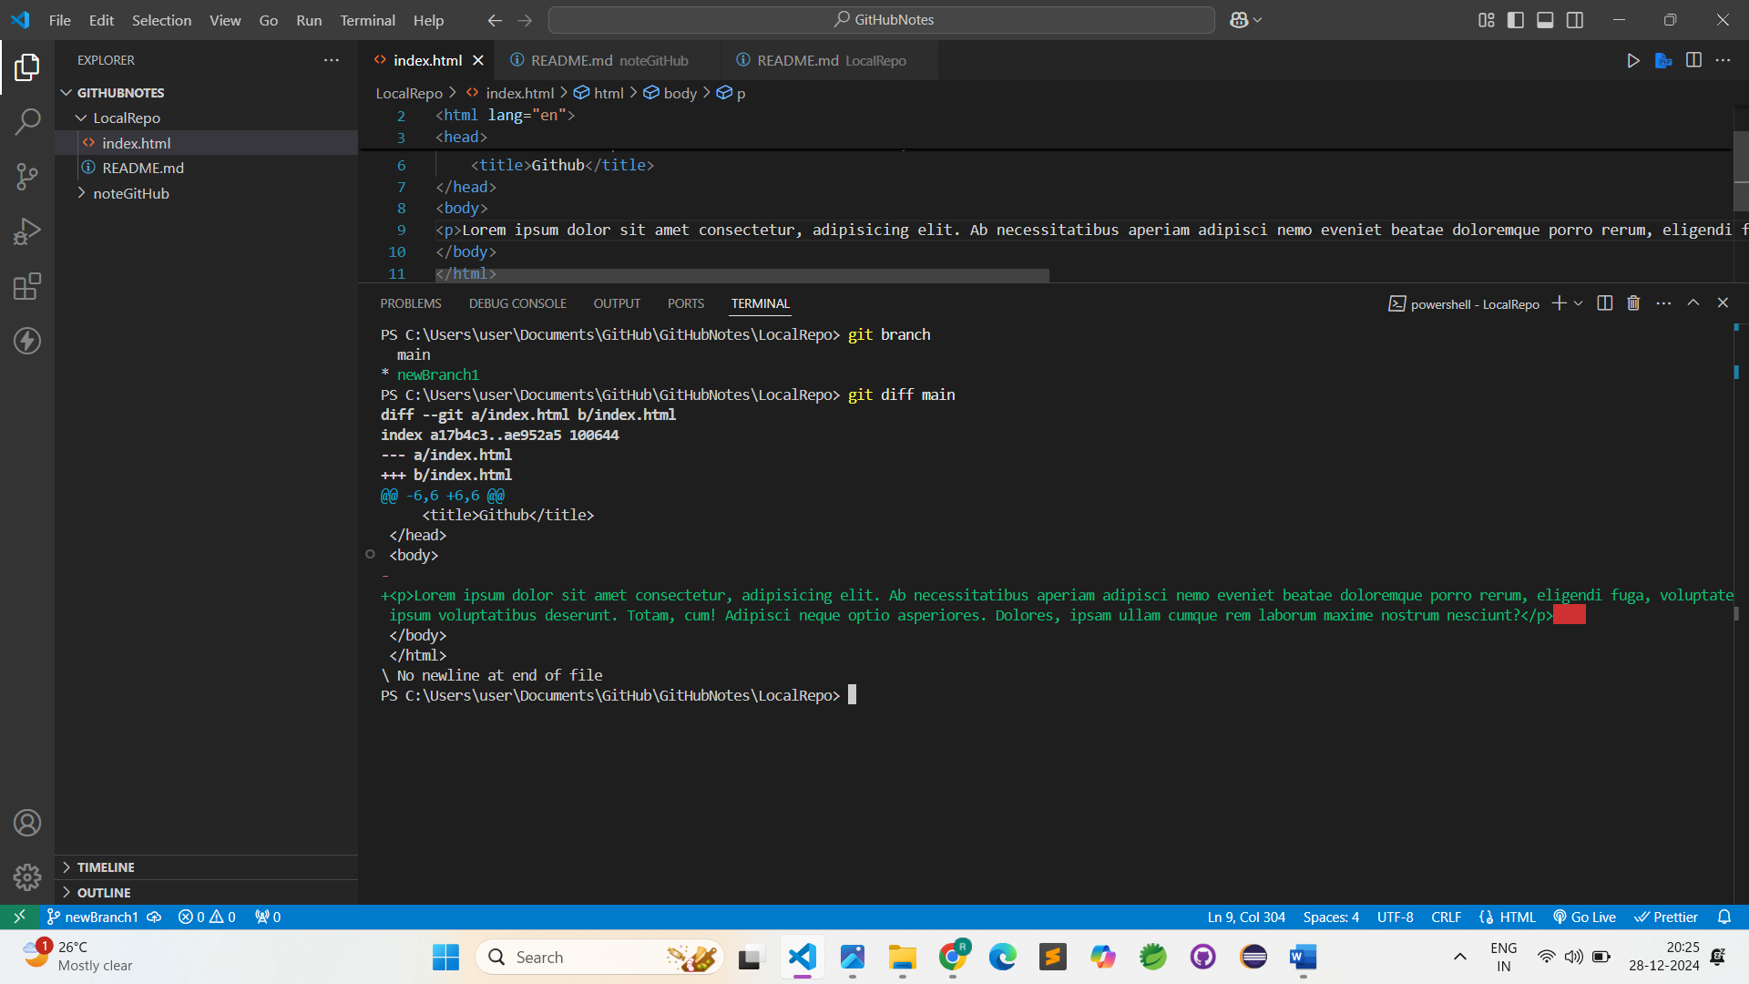

### 2)Create PR (Pull Request)

But little bit confusen also you can practies perfect

1)

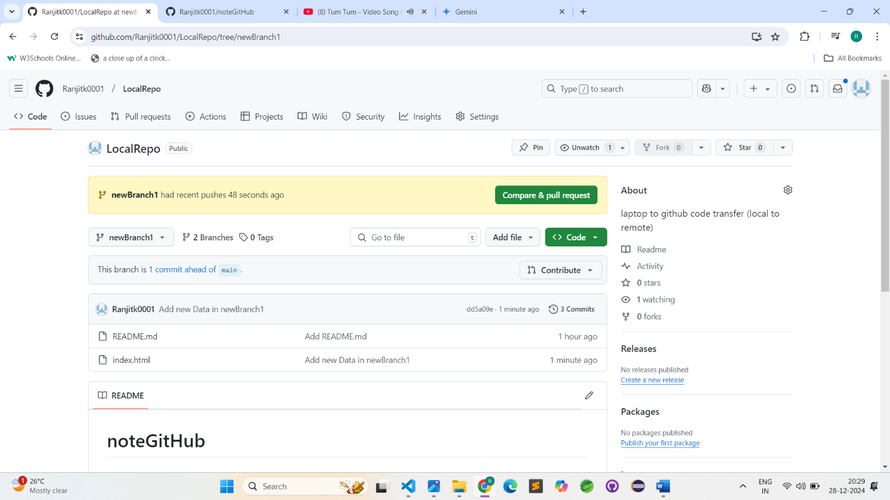

2)

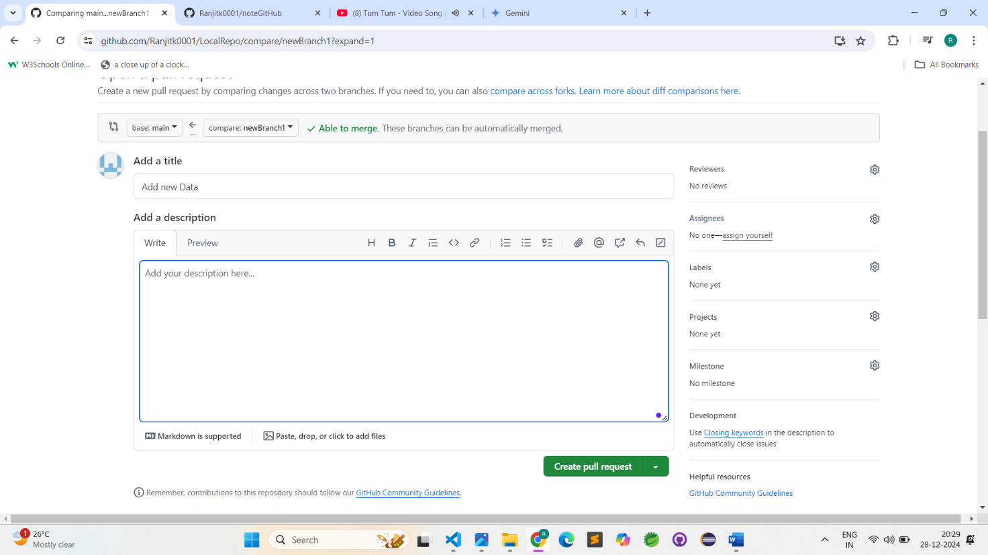

3)

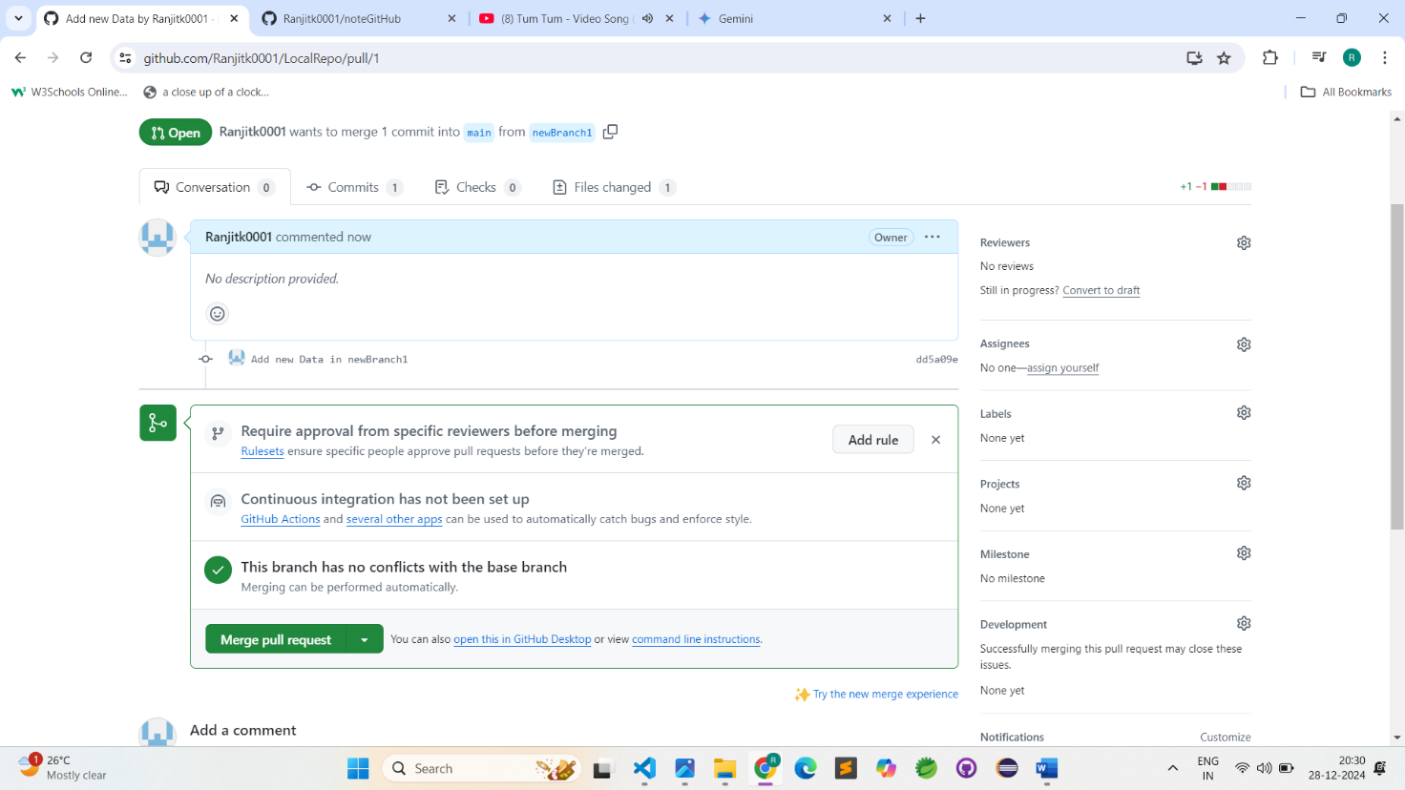

4)

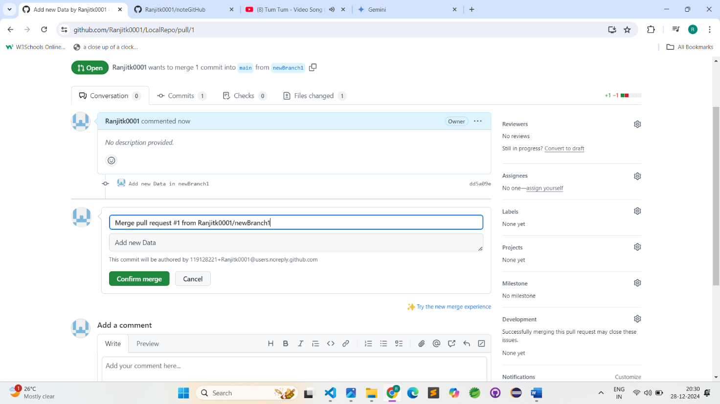

5)

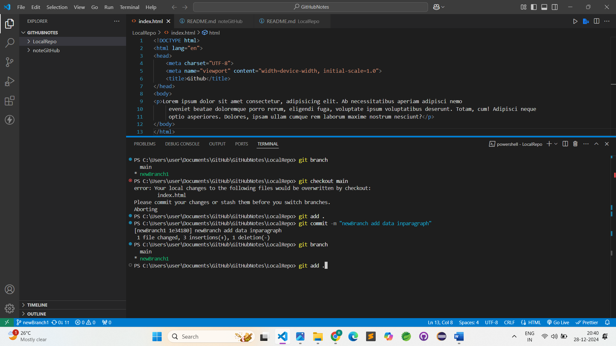

6)

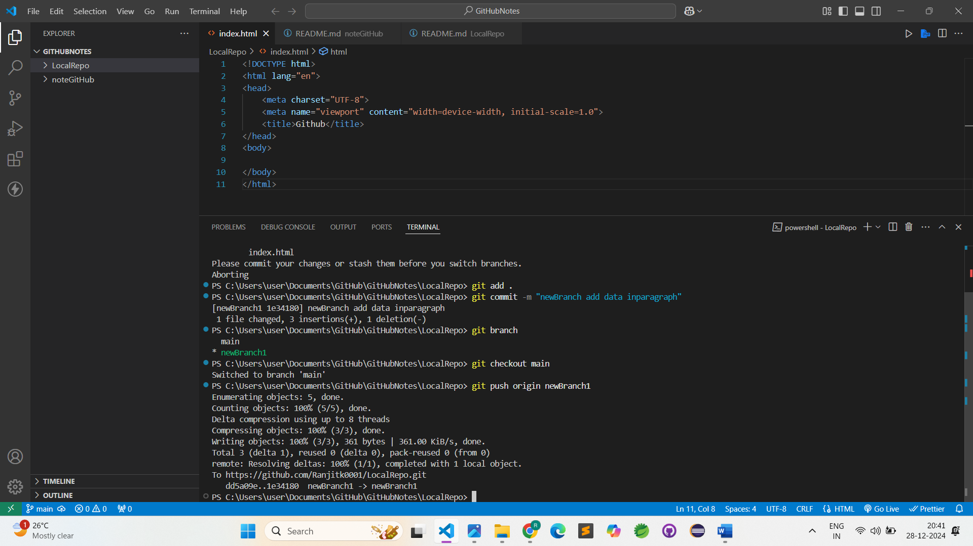

7)

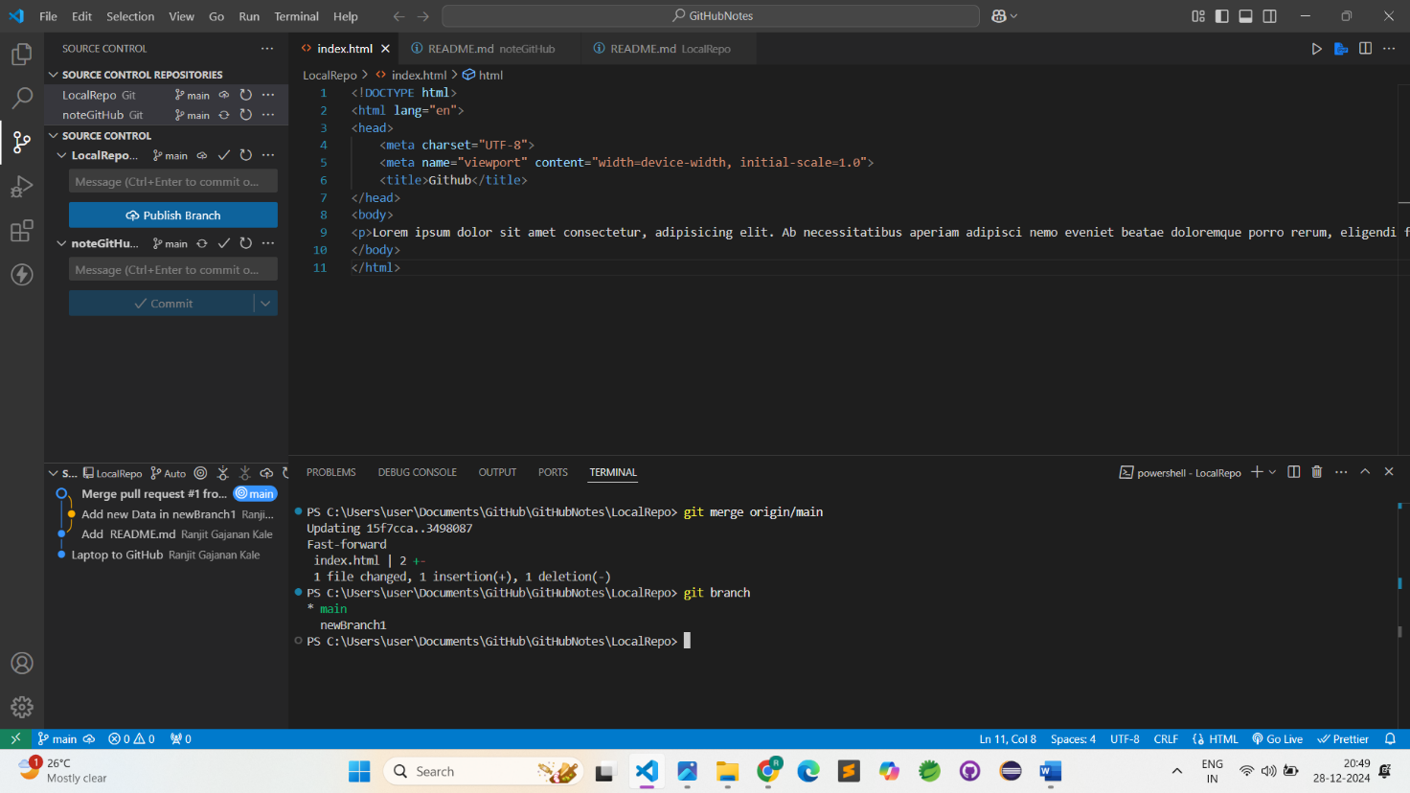

## Pull Command

**Git pull origin main**

Used to fetch and download content from a remote repo and immediately update the local repo to match that content.

Add the photo(**ex:- 1450**) with normal and updated

## Resolving Merge Conflicts

An event that takes place when git is unable to automatically resolve differences in code between two commits.

1)

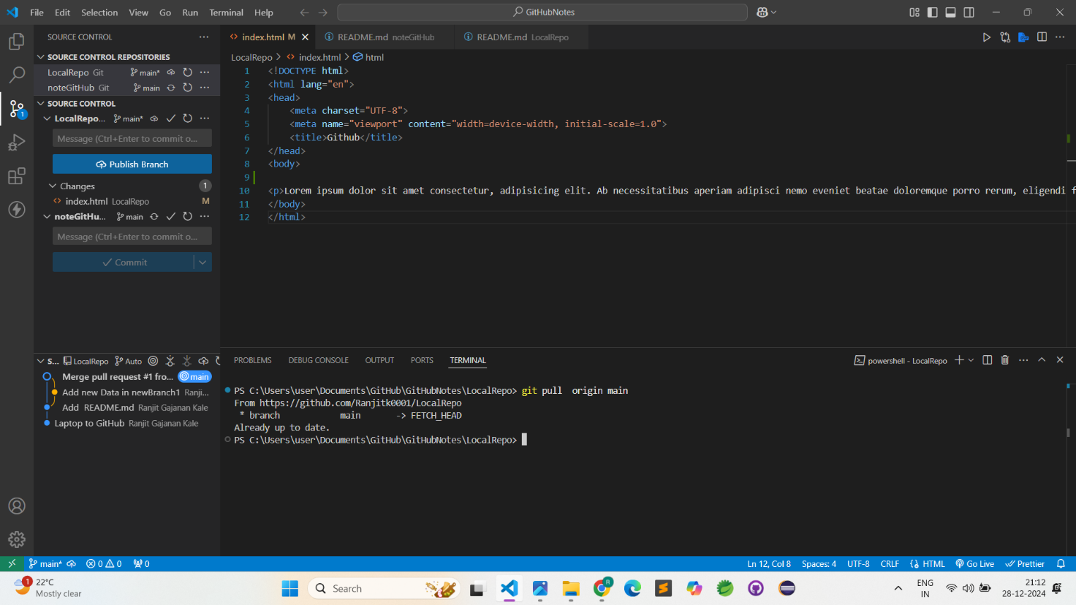

2)

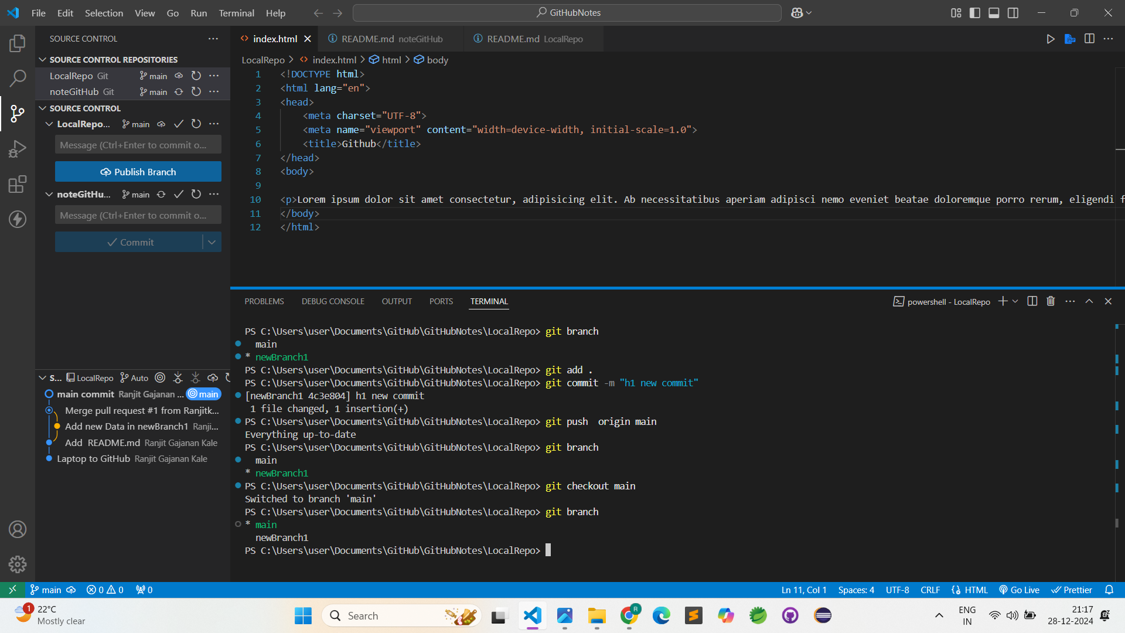

3)

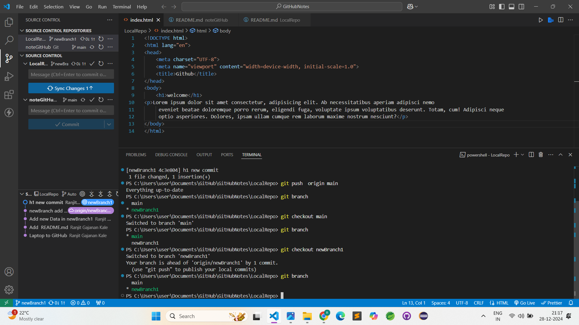

4)

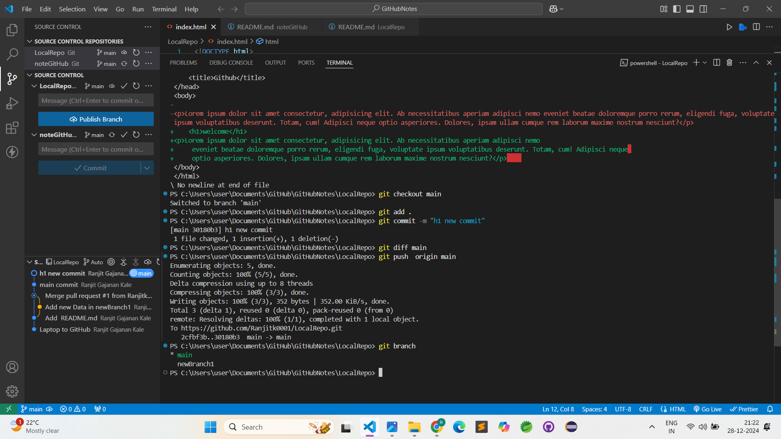

5)

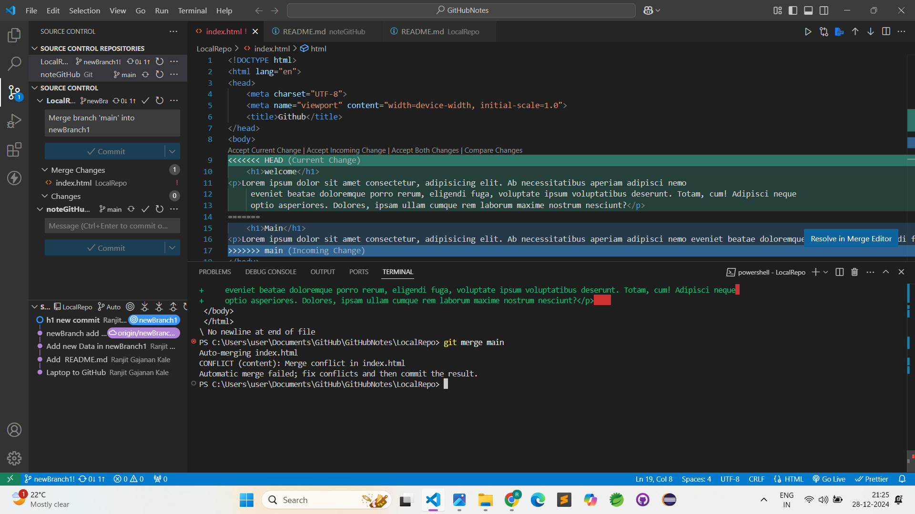

6)

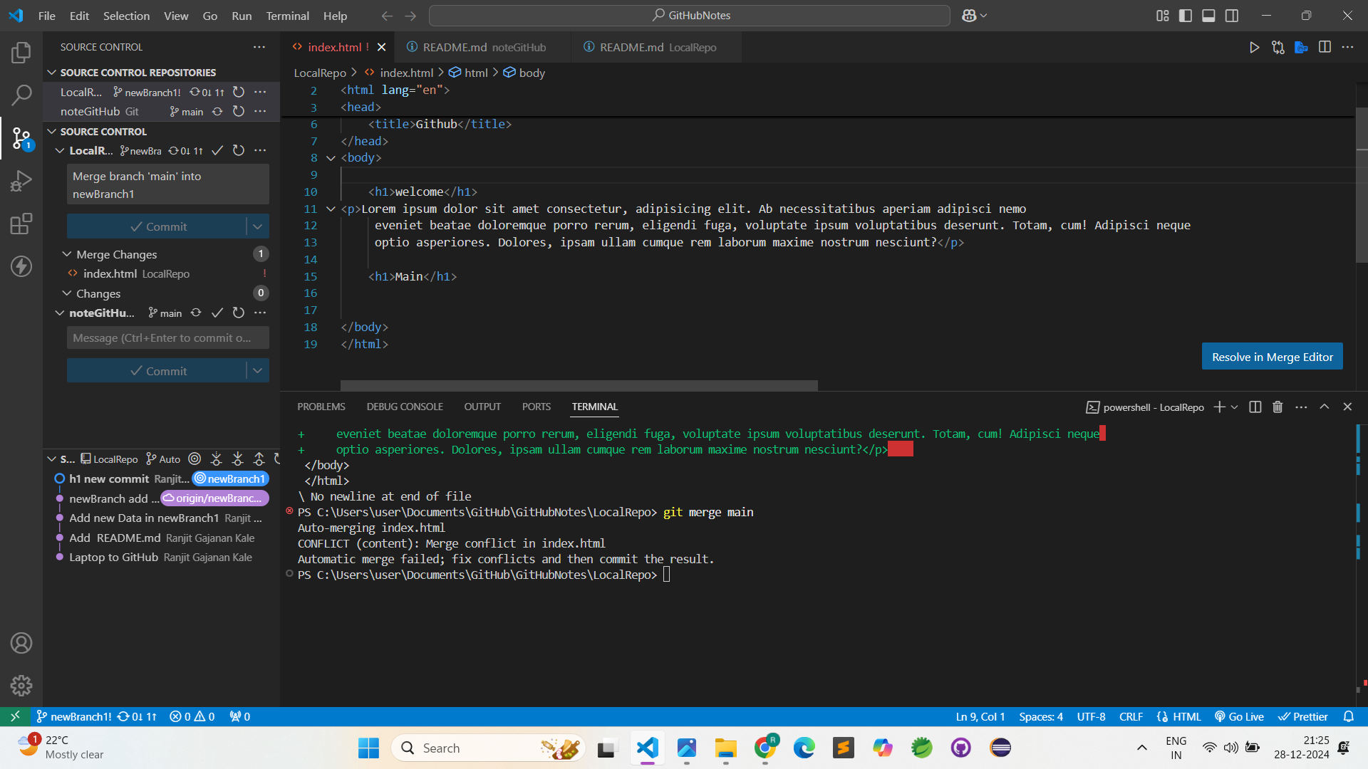

7)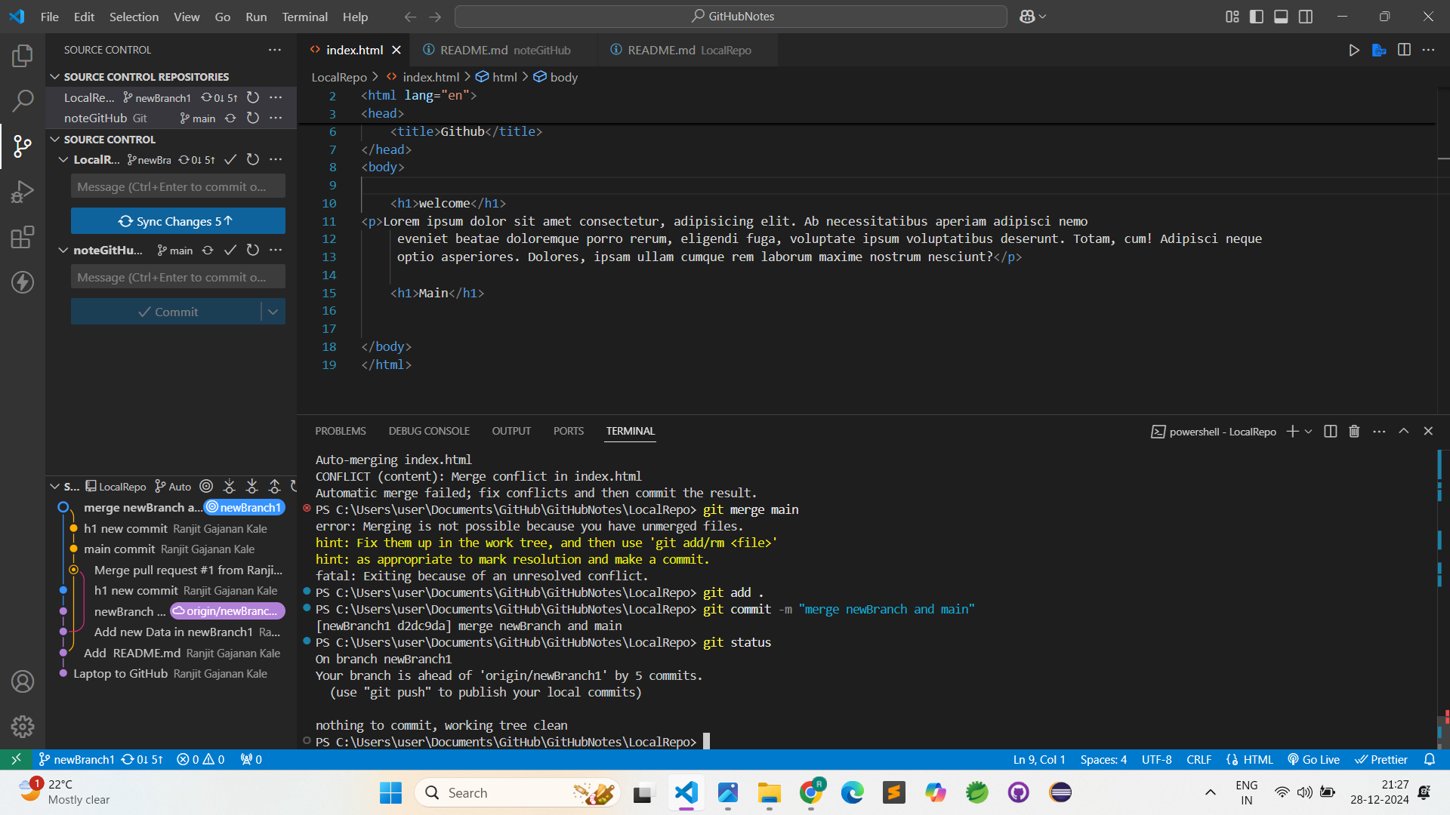

8)

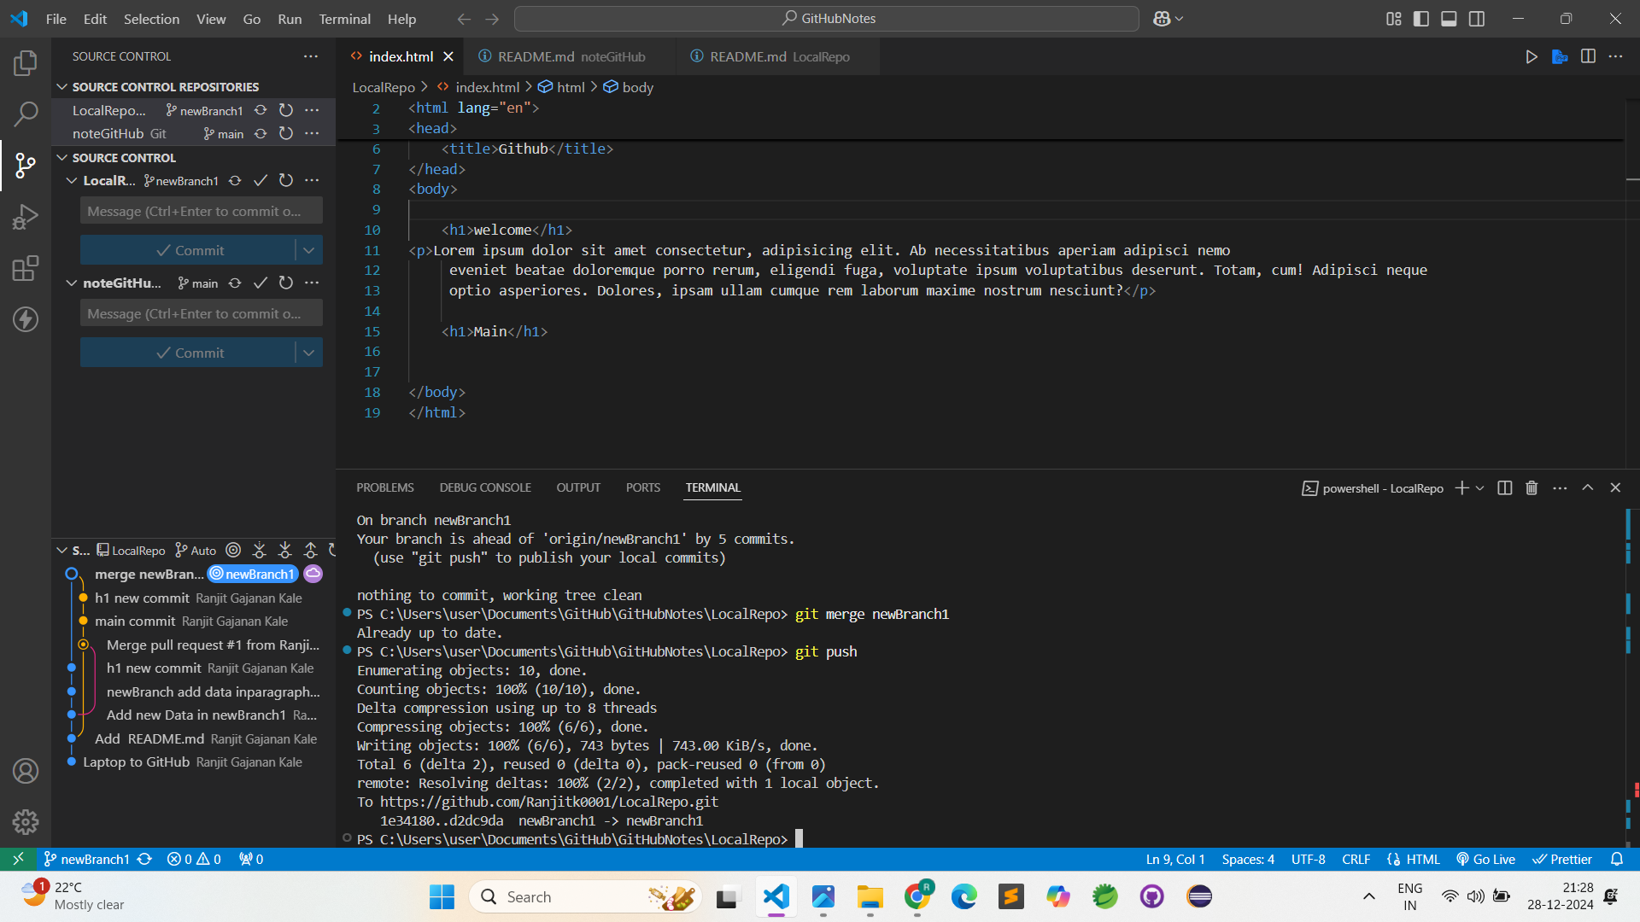

9)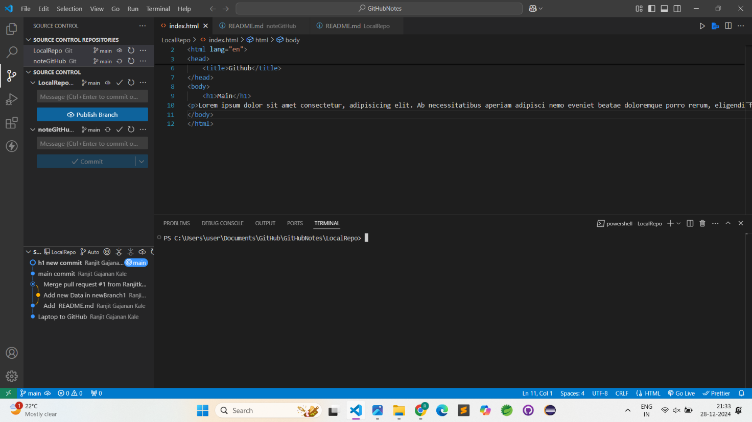

10)

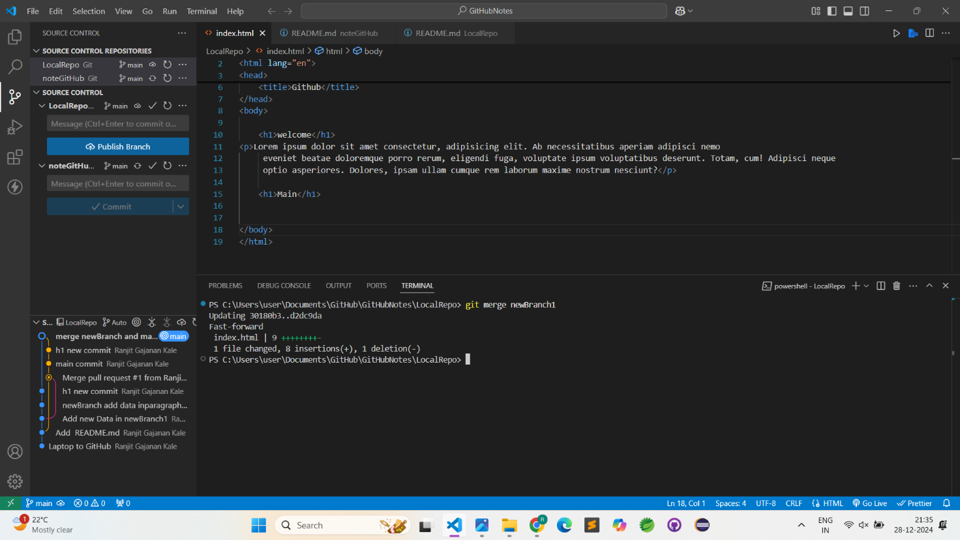

11)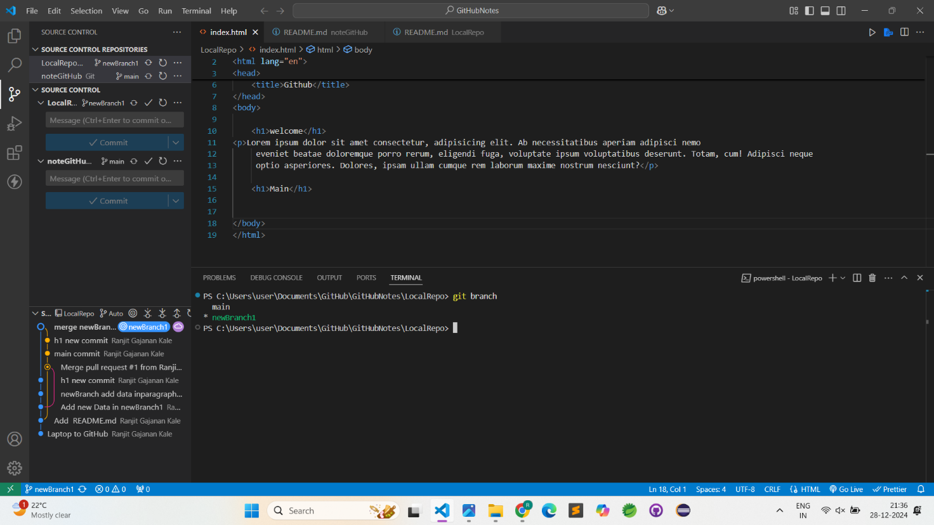

12)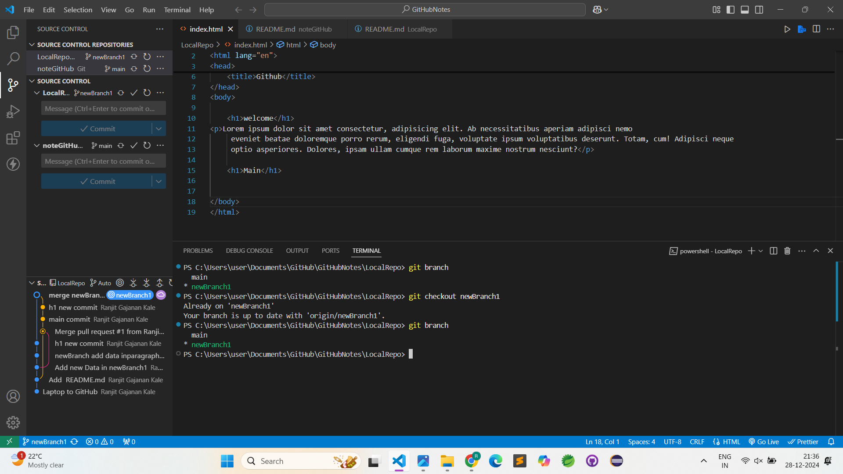

## Undoing Changes

### Case 1: staged changes

(add . used after this command used)

git reset <-file name->

git reset

1)

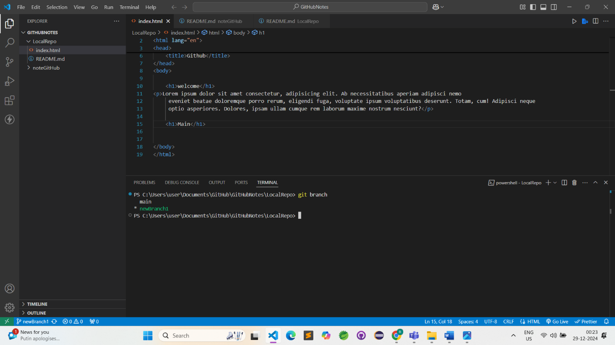

2)

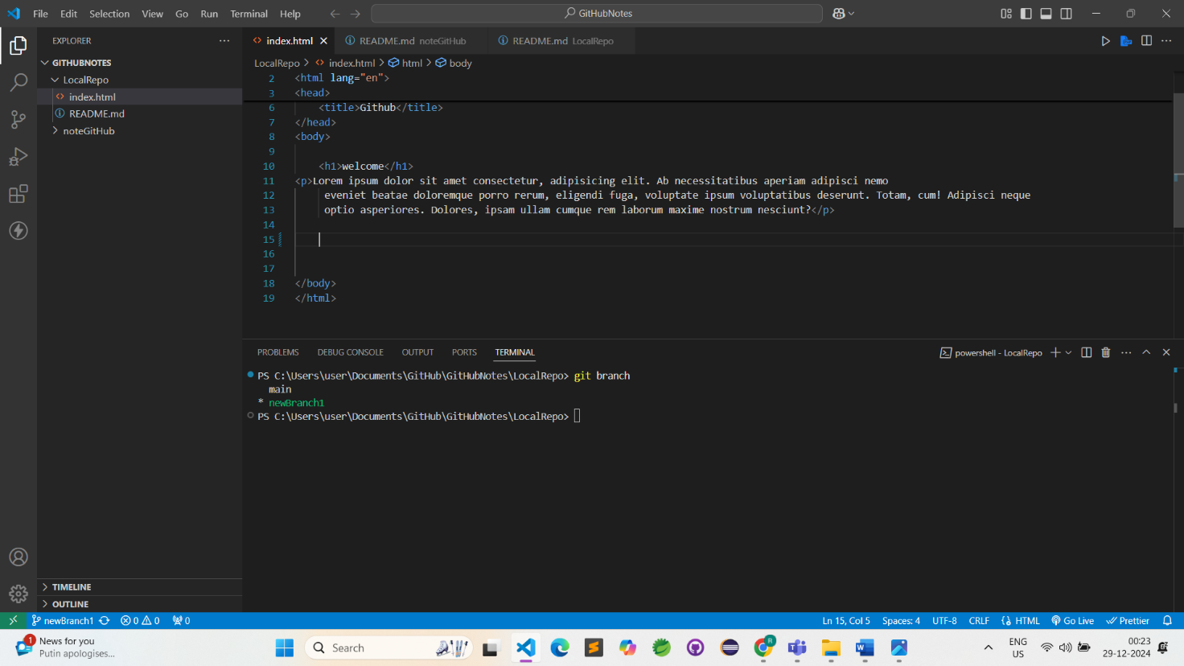

3)

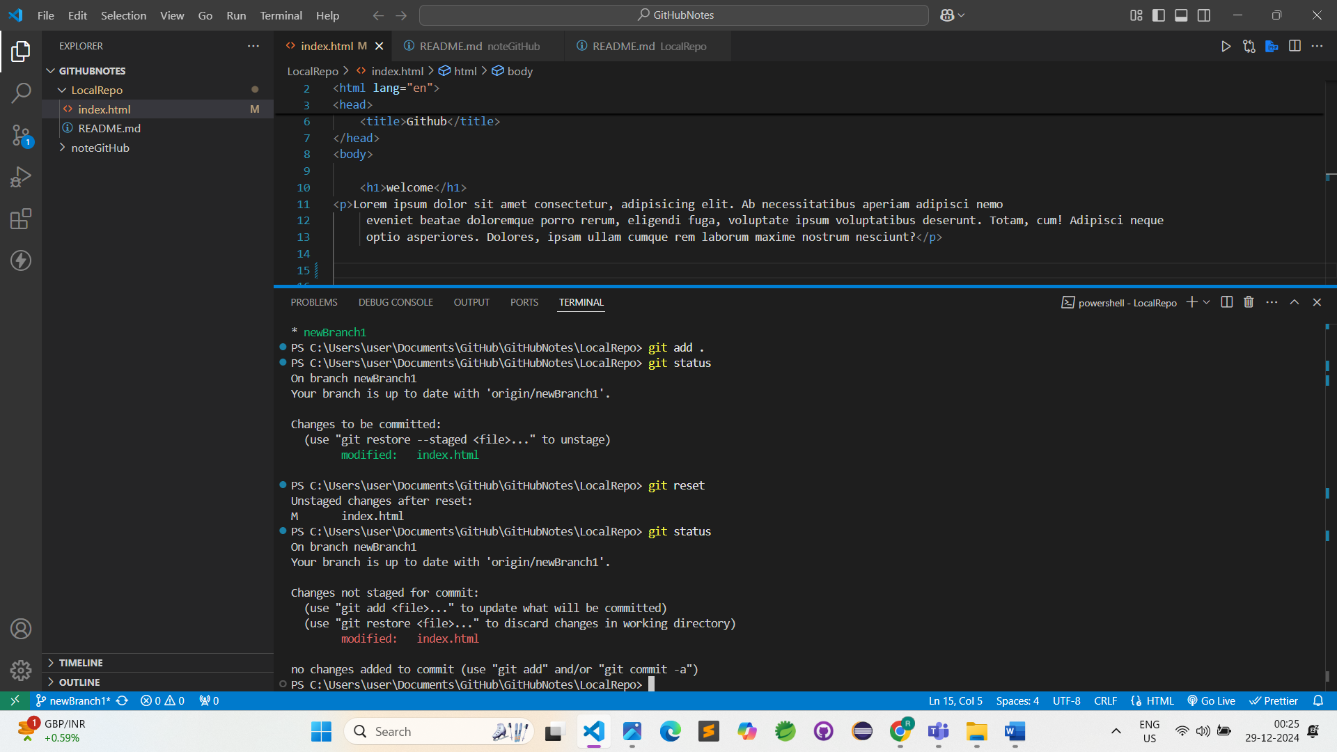

### Case 2: Commited changes (for one commit)

git reset HEAD~1

1)

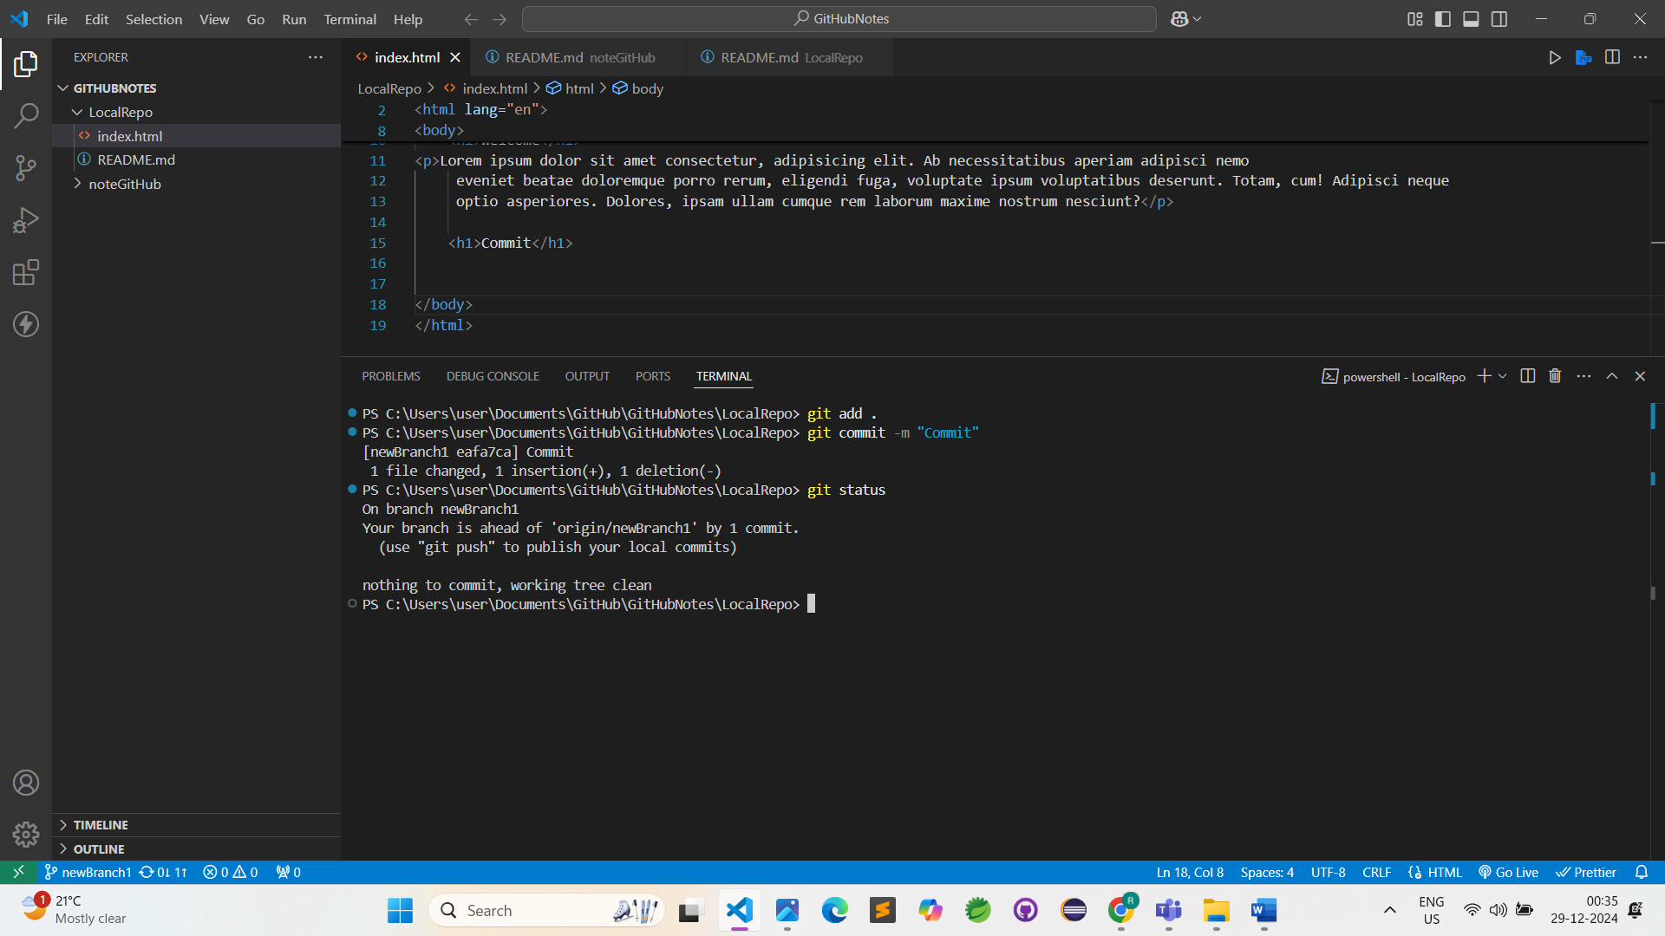

2)

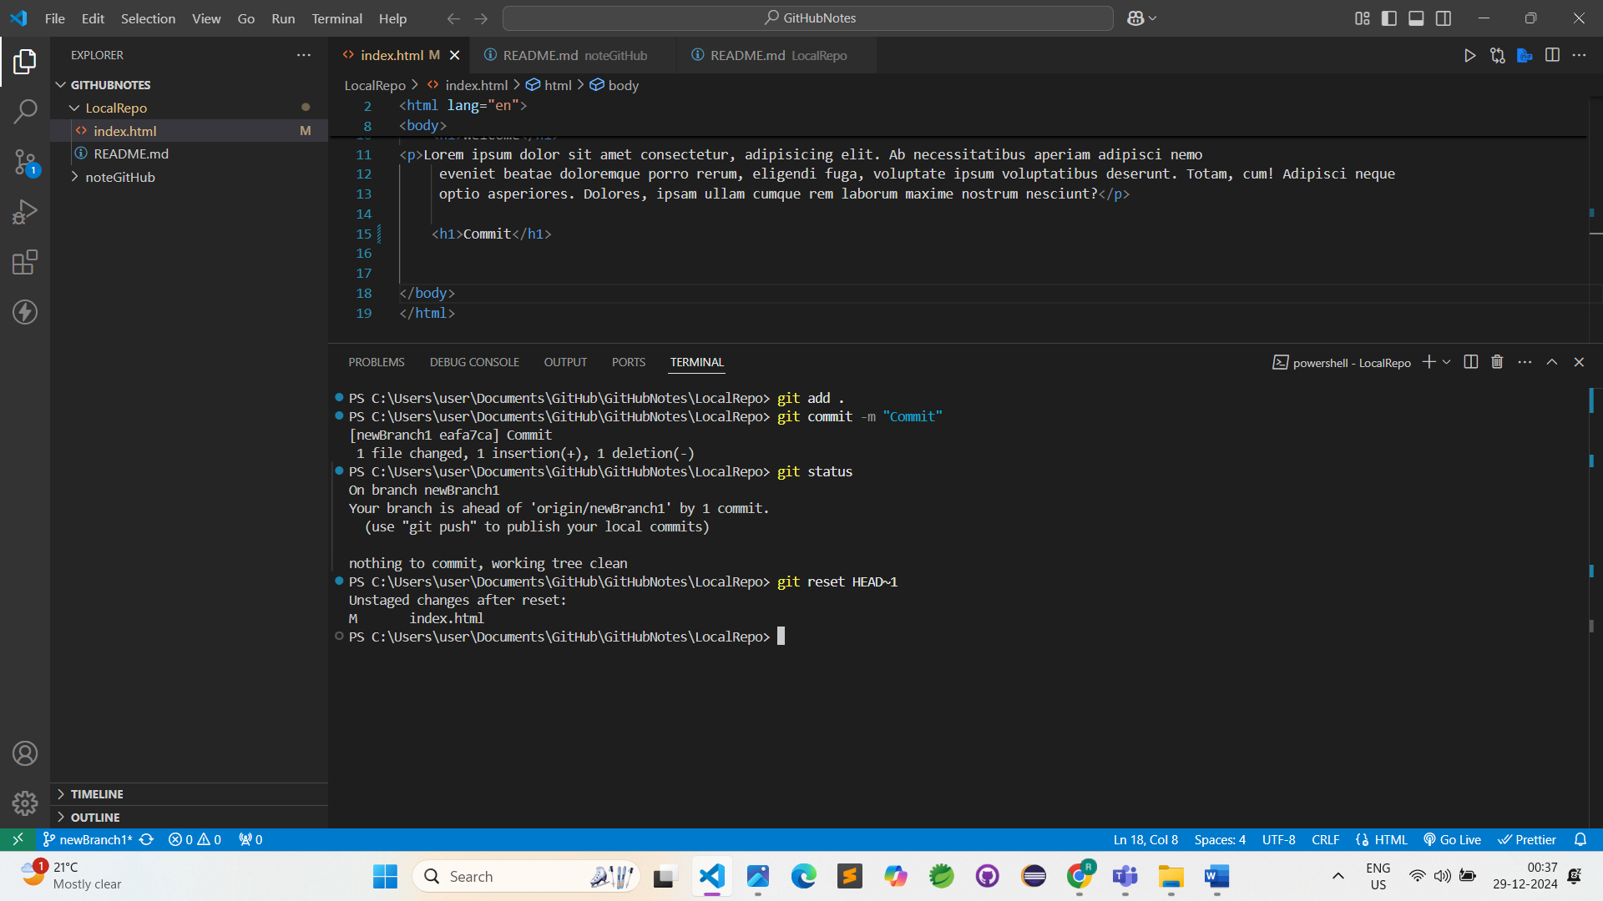

3)

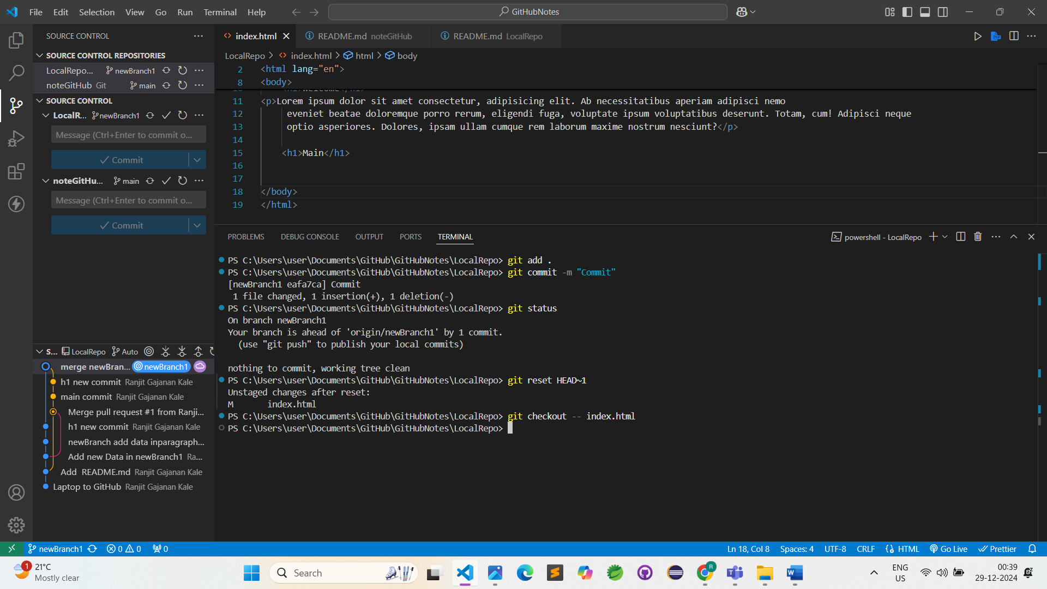

### Case 3: commited changes (for many commits)

git reset <-commit hash->

git reset –hard <-commit hash>

## Push on site commit Deleted

1)

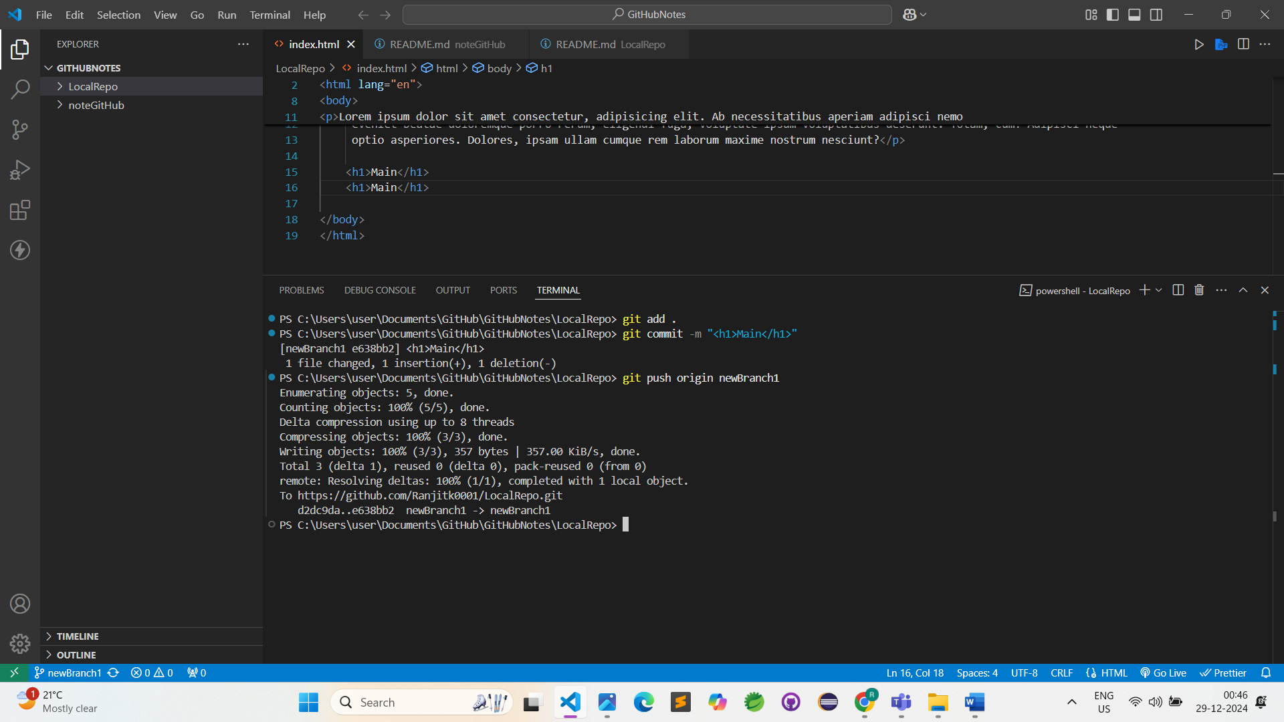

2)

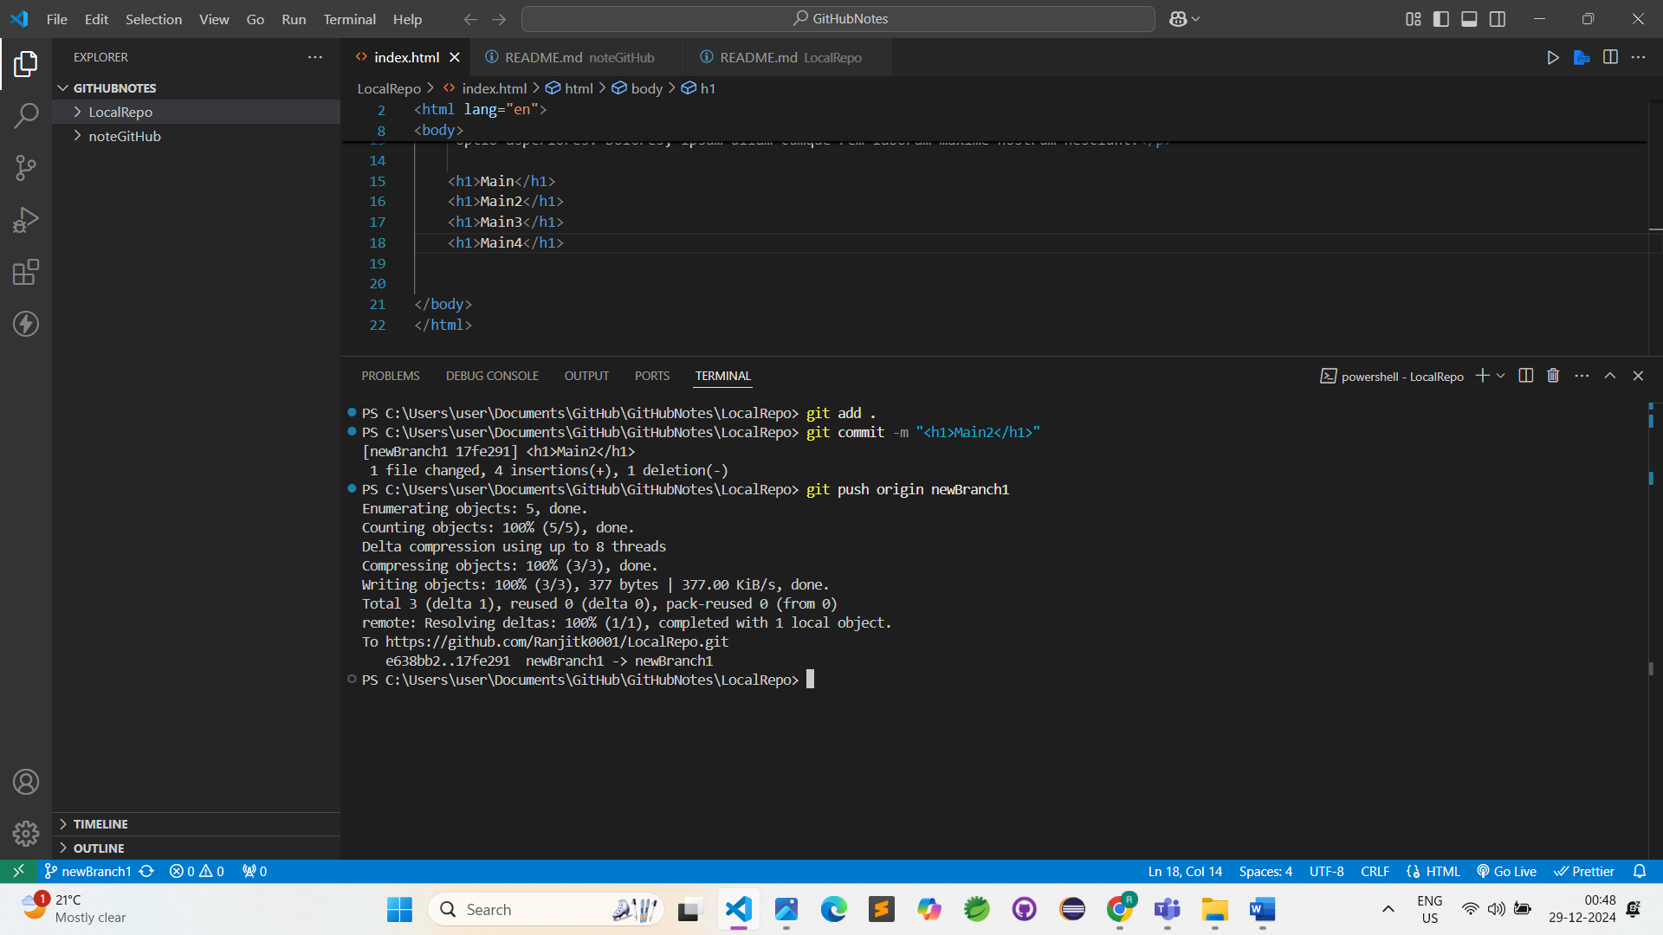

3)

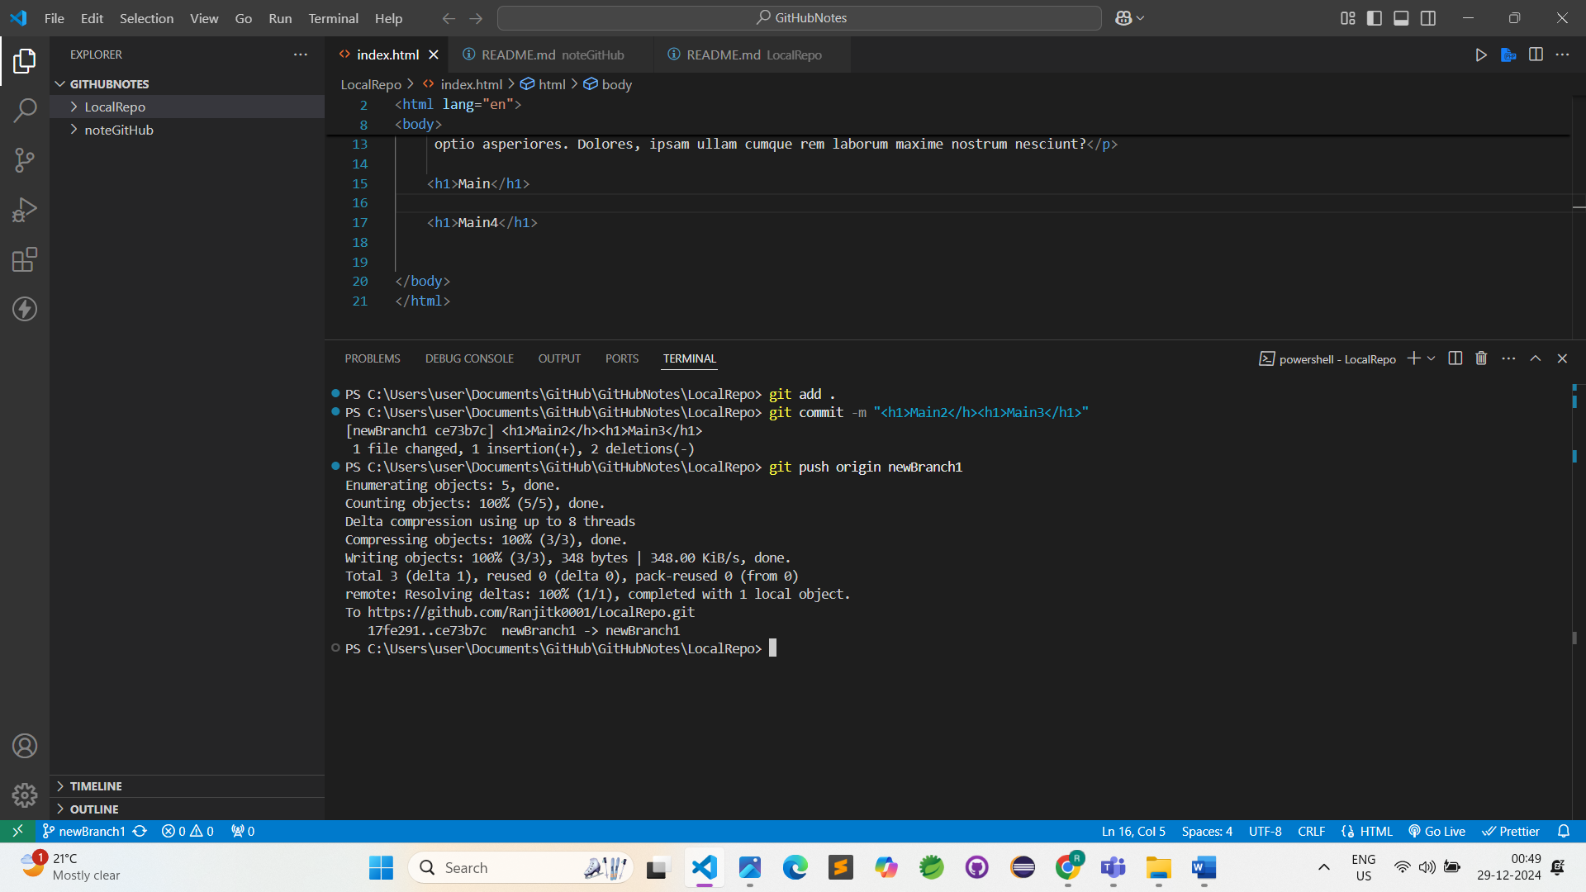

4)

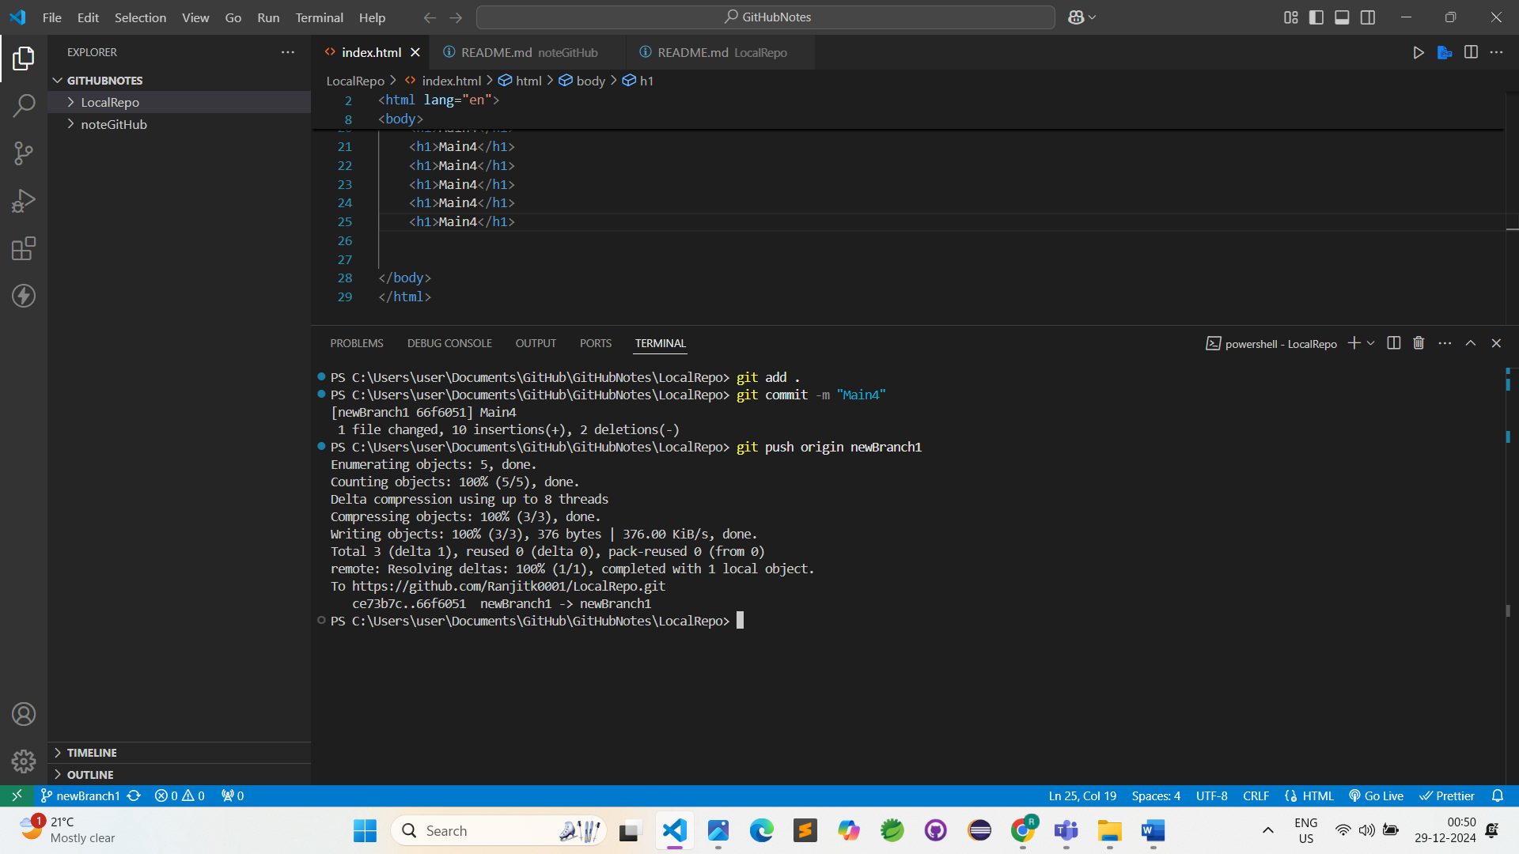

5)

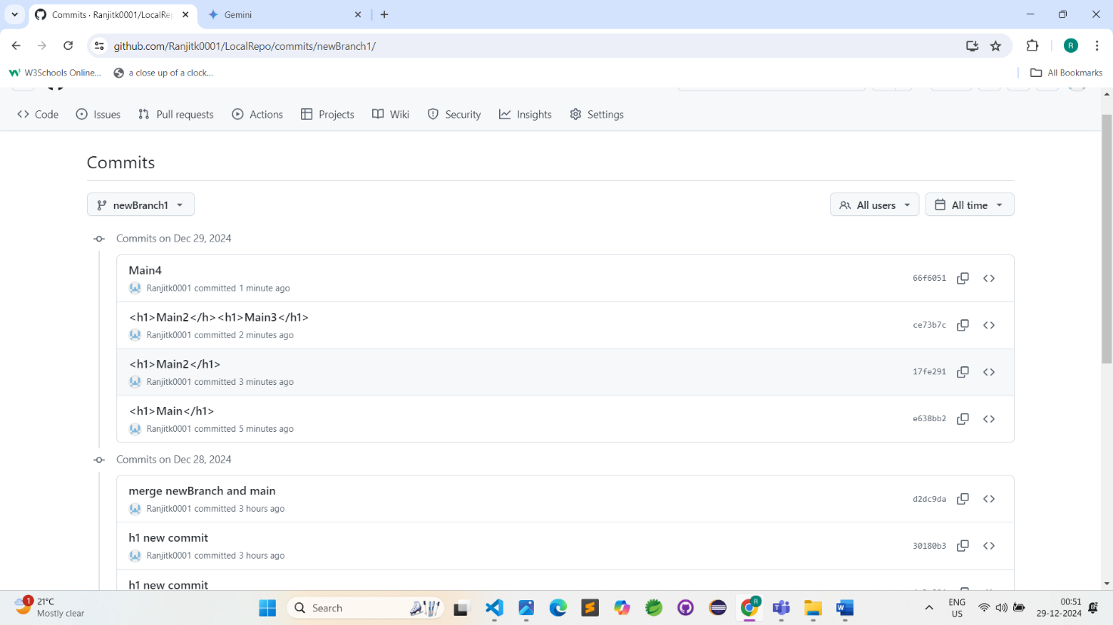

6)

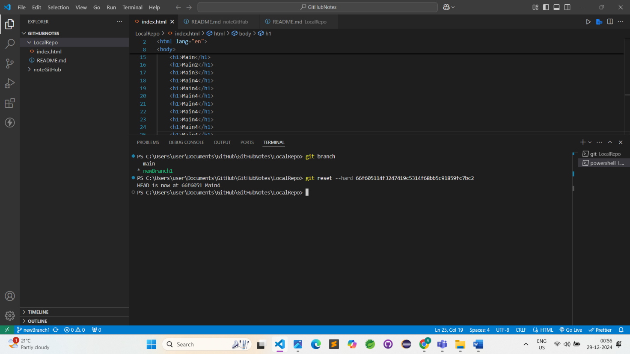

7)

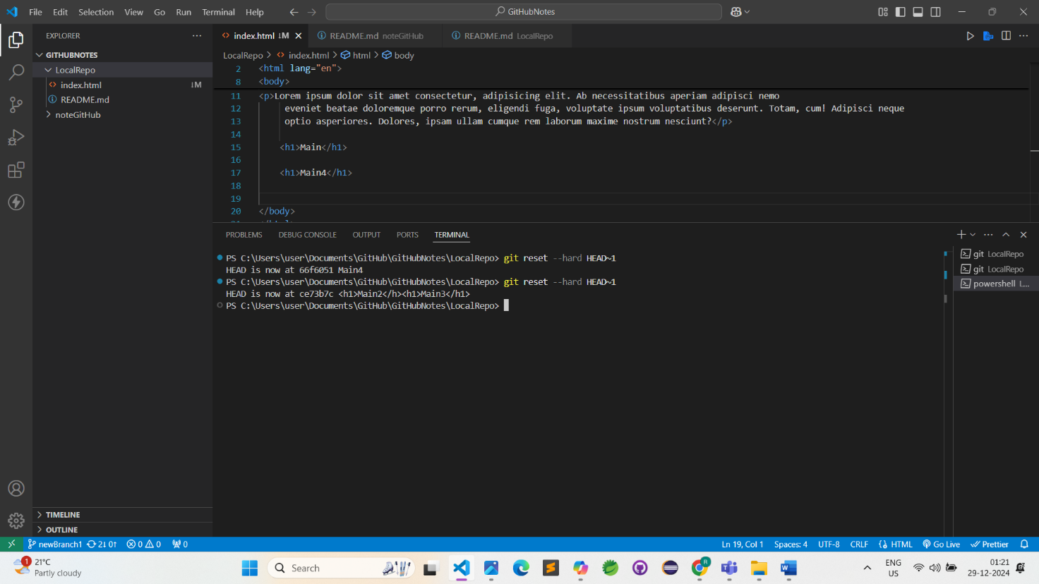

8)

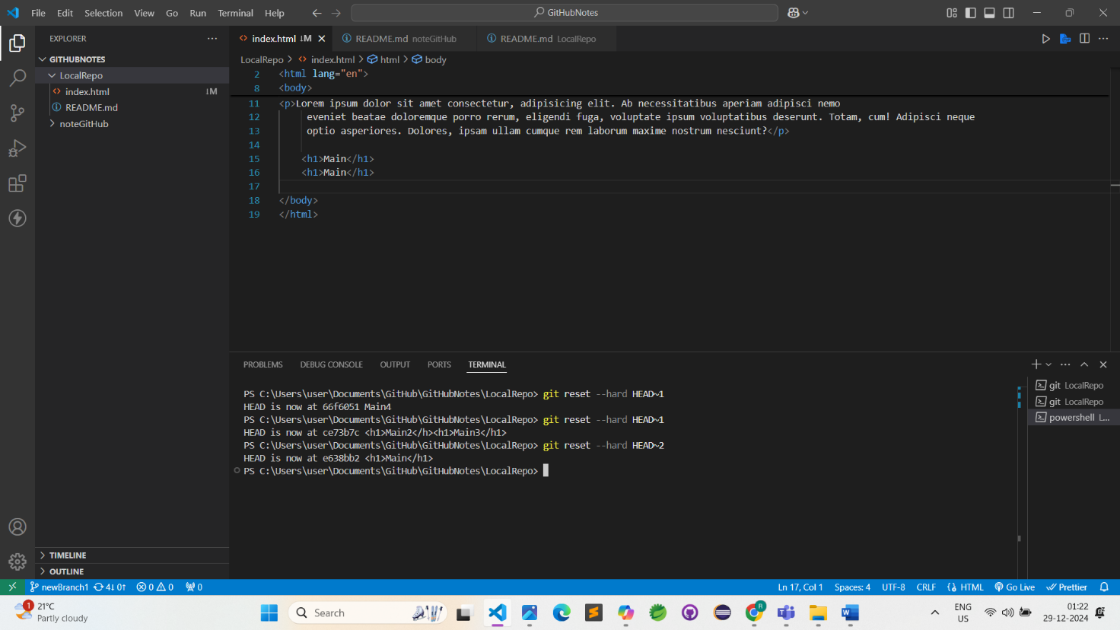

9)

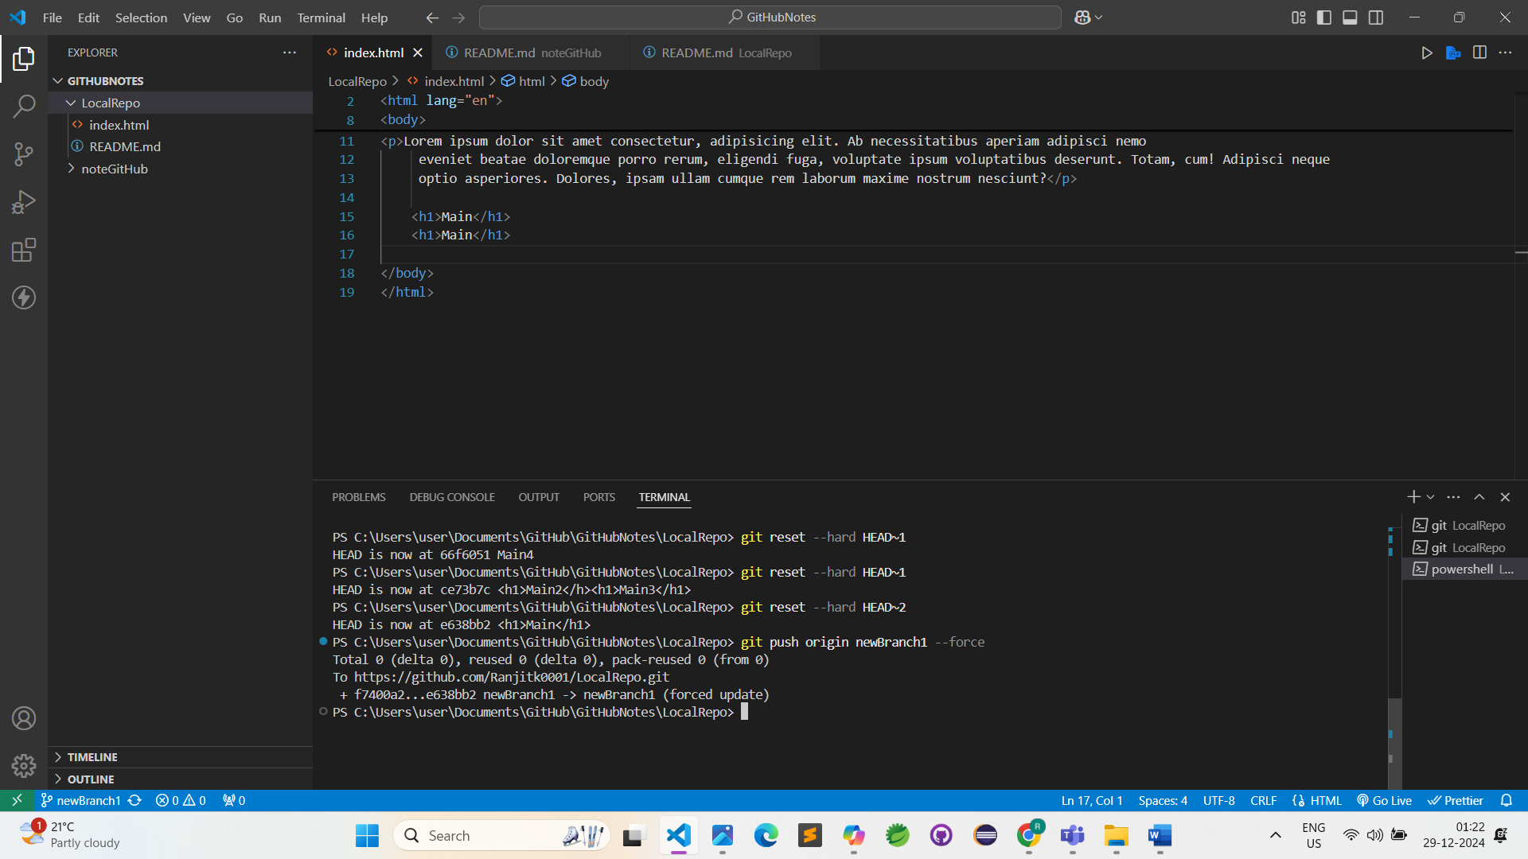

10)

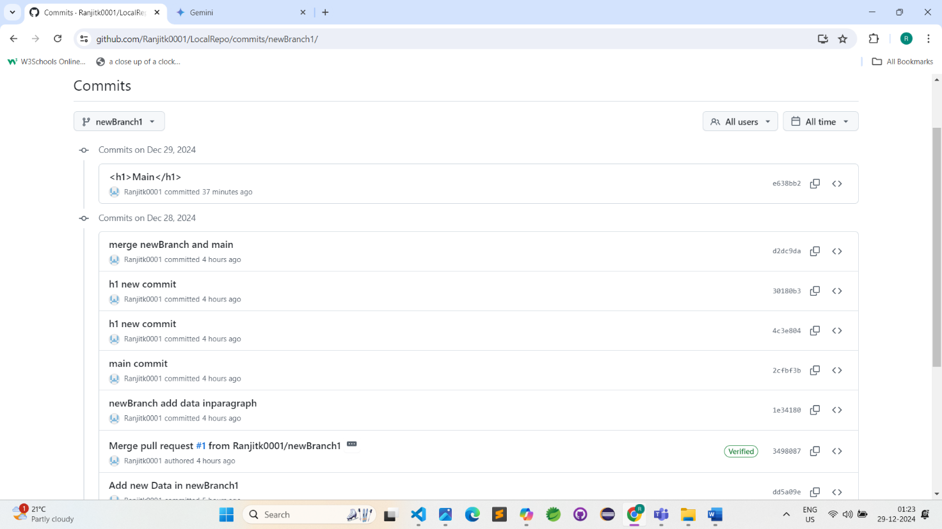

11)

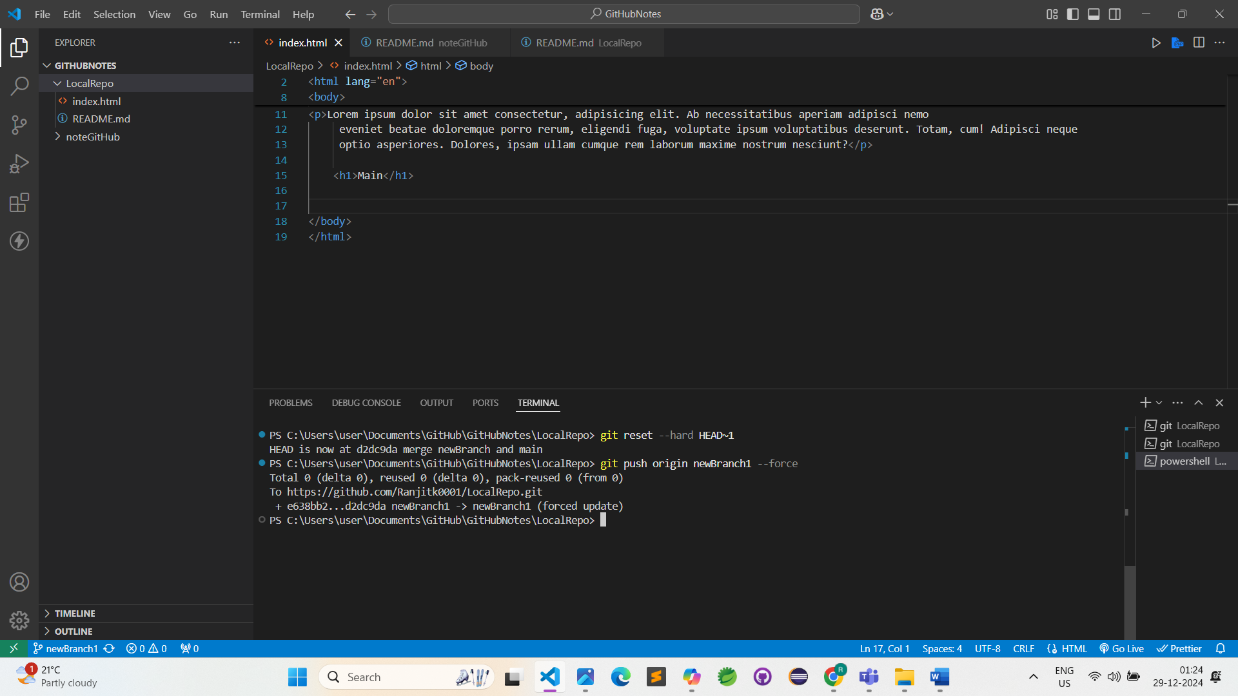

12)

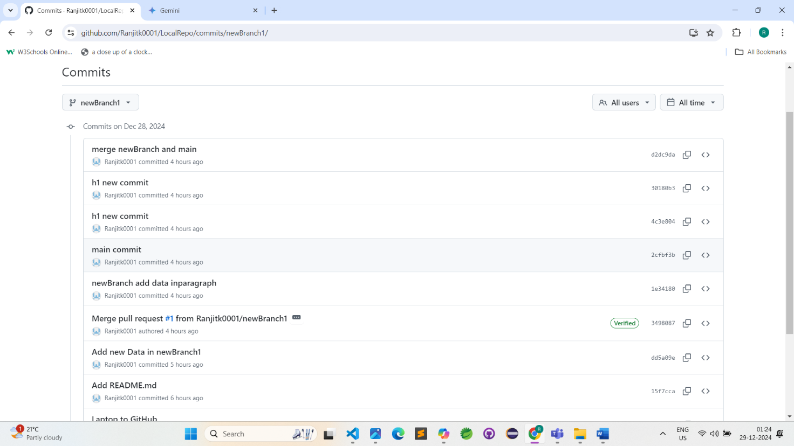

## Fork

**A fork is a new repository that shares code and visibility setting with the original “upstream” repository.**

**Fork**  is a rough copy.

1) <https://github.com/ranjitkale9696/Fork->

2) <https://github.com/Ranjitk0001/Fork--create-copy>

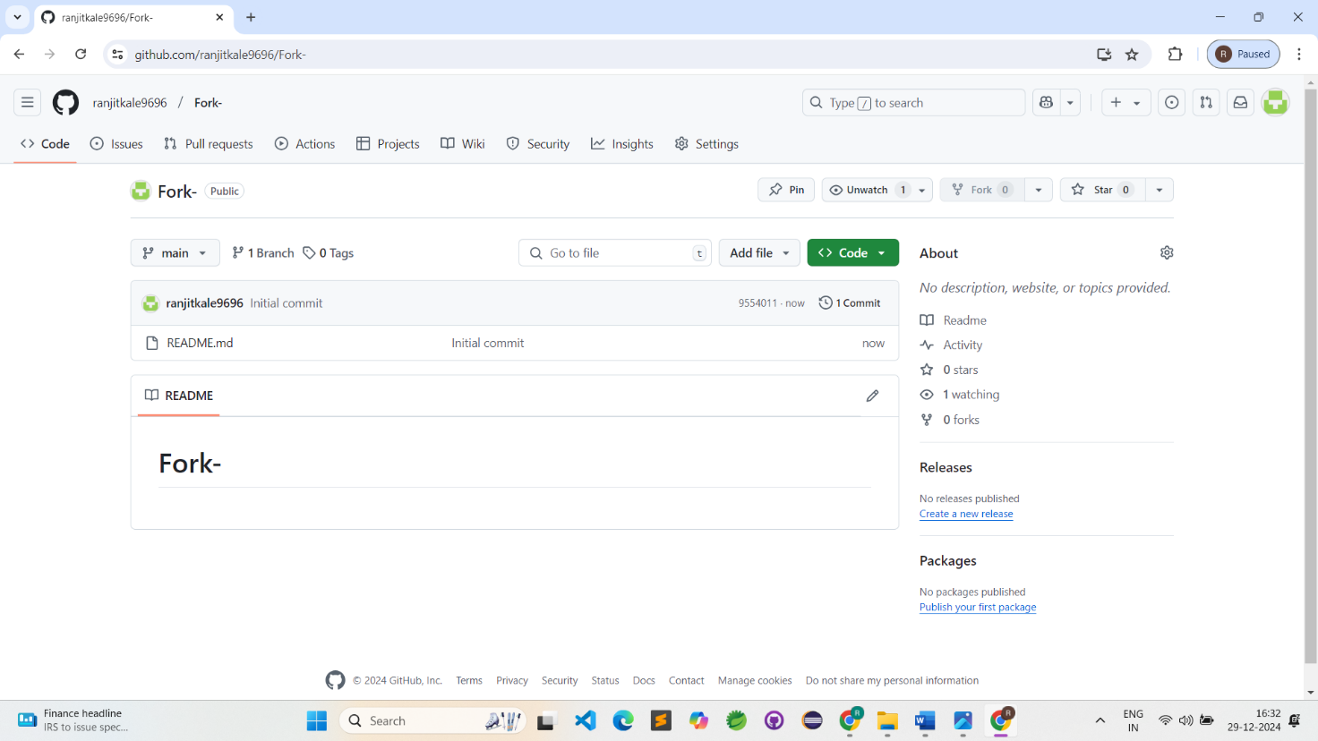

2)

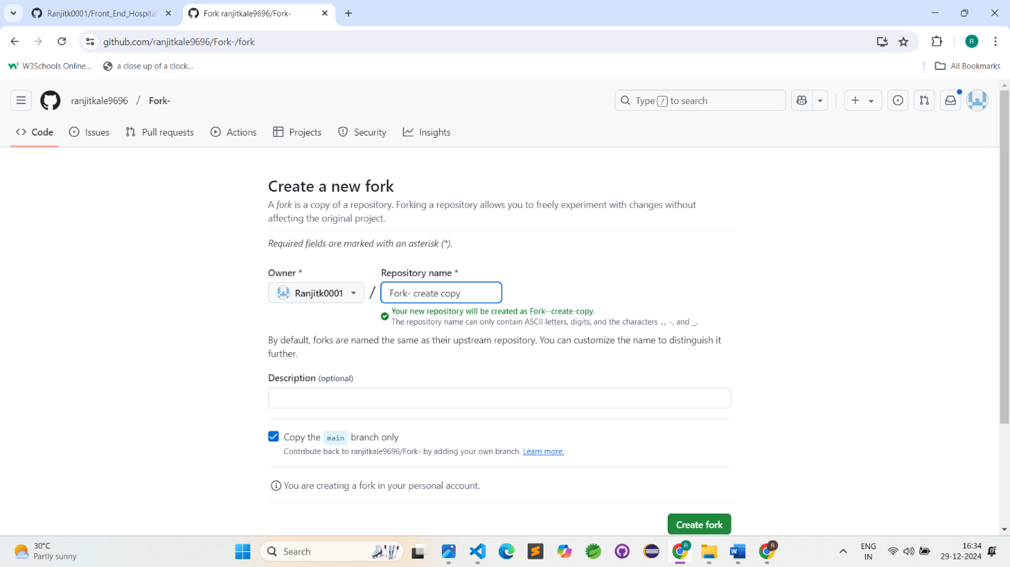

3)

